CRC Proprietary

  (Classification)

TECHNICAL MEMORANDUM / MÉMOIRE TECHNIQUE

Date: January ??, 2017

Serial No. VPWT #??/17

No de série

Branch: Wireless Technologies Branch (VPWT)

Secteur:

Section: Signal Processing (RSP)

Directorate:

Title: **Development of Spatial Agility Capability Assessment/Visualization System**

Titre:

Author(s): Zhiwen Zhu and Xinping Huang

Auteur(s):

Electronic

Distribution: S. Gagnon (VPWT)

J. Lodge

A. Florea

P. Vigneron

A. Petosa

RSP

NOTE: A Technical Memorandum is NOT a formal CRC publication; it is a working document produced in a Laboratory during the course of a research project. It has a restricted distribution and is available outside the institute only by special arrangement. Hence, it must not be cited in the open scientific literature as a reference.

NOTE: Un mémoire technique n'est PAS une publication du CRC; c'est un document de travail produit dans un laboratoire, dans le cadre d'un projet de recherche. Sa distribution est restreinte et il peut être obtenu à l'extérieur de l'institut par accord spécial seulement. Par conséquent, les publications scientifiques ne peuvent pas l'indiquer comme document de référence.

Table of Contents

Abstract 1

1 INTRODUCTION 2

2 SYSTEM OVERVIEW 3

2.1 Features 3

2.2 Propagation Measurement 4

2.3 User Interface and Visualization 5

3 SYSTEM FUNCTIONALITIES 8

3.1 Multipath Propagation Characterization 8

3.2 Coverage Heat Map Calculation 10

3.3 SNR Calculation 12

3.4 Channel Capacity Calculation And Visualization 13

4 FUTURE ENHANCEMENTs 17

4.1 Antenna Characteristics 17

4.2 Ray-Tracing Model 17

4.3 More User Cases 18

4.4 Spectrum Efficiency Assessment 18

4.5 Array-based Propagation Measurement 18

4.6 Migration to Cloud Implementation for BDAC Demonstration 19

5 CONCLUSION 20

References 20

Appendix: Source Code 20

# 

# Abstract

To be completed.

**Development of**

**Spatial Agility Assessment and Visualization System**

# INTRODUCTION

For the Breaking the Frequency Barrier (BFB) Grand Challenge, utilizing spatial domain information in a complex multipath propagation and scattering environment is seen as a key enabler to support mobile broadband communications at frequencies above 6 GHz, where abundant spectrum is available, but unique propagation-related challenge also exists. The BFB Spatial Agility Capability Assessment project is designed to assess the potentials of mobile broadband communications at frequencies above 6 GHz, and to develop technologies to exploit the benefit of spatial diversity and spatial multiplexing to enhance and improve the communication system performance and capacity.

To facilitate the spatial agility capability assessment, the propagation measurement was conducted in various indoor/outdoor locations to allow us to understand the propagation environment. In addition, we have developed a spatial agility capability assessment and visualization platform in Matlab. It allows us to assess and illustrate various characteristics and performance, such as propagation (coverage heat map), signal to noise ratio (SNR) heat map, channel capacity of SISO, SIMO, MISO and MIMO systems by fusing the propagation measurement, spatial agility processing and visualization.

This report describes the spatial agility capability assessment and visualization platform. It is organized as follows: Section 2 provides a system overview; the features and functionalities of the spatial agility capability assessment and visualization platform are described in Section 3, with examples; and Section 4 discusses future enhancements, while Section 5 concludes the report. The Matlab source code is included in Appendix.

# SYSTEM OVERVIEW

The spatial agility capability assessment and visualization platform combines outputs of the propagation measurement project and the spatial agility project of CRC’s Break Frequency Barrier Grand Challenge program. Developed in Matlab, this platform provides us with a flexible research environment to visually examine and investigate propagation environments (heat map, multipath propagation), to explore the spatial agility gain, and to evaluate and quantify the communication system capability of SISO, SIMO, MISO and MIMO systems.

## 

## Background on Propagation Measurement

A number of propagation measurements have been carried out at several frequency band and different areas [1]. Figure 2.2 shows an example of indoor propagation measurements conducted on the second floor of Building 2C at the CRC campus. In the figure, a double circle labelled with “Tx” identifies the location of the channel sounding transmitter, which closes to the left edge of the floor and is fixed during the propagation measurement. The receiver is positioned at different locations identified by numbers from 1 to 35 enclosed in double circles. Both the transmitter and the receiver employ a single horn antenna that rotates at the 10° step in the full 360° in azimuth and from -30° to 50° in elevation. At each receiver location, the measurement was conducted at frequencies from 2.4 GHz to 61 GHz, and post processing was carried out to derive multipath propagation components (MPCs) at each frequency for both horizontal and vertical polarizations [1].

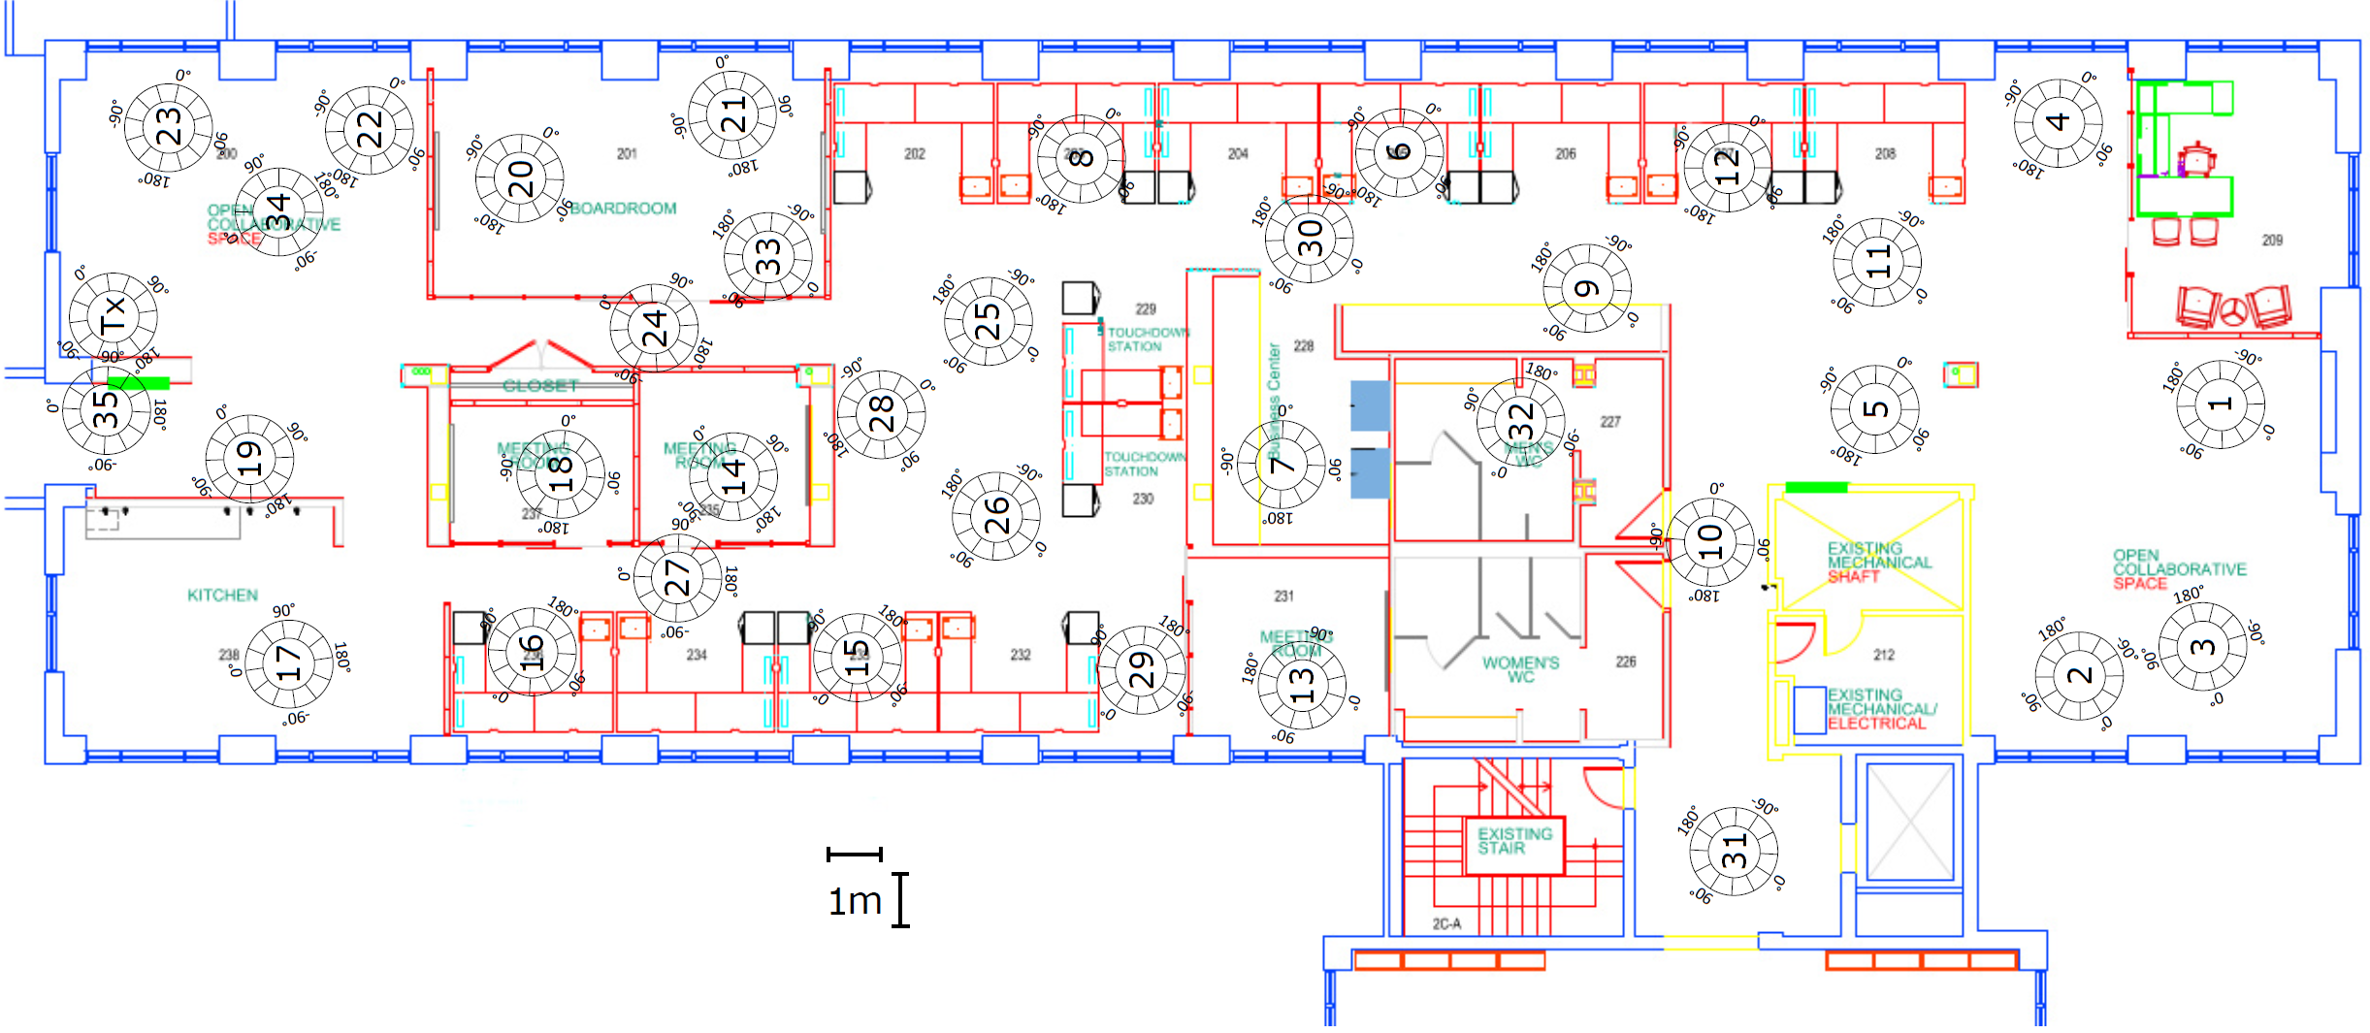

Figure 2.1: One example of indoor propagation measurement setup at CRC.

Each MPC is represented by an angle of departure (AoD) from the transmitter, a path gain, and an angle of arrival (AoA). At each receiver location, 1000 MPCs are derived from the measurement. Figure 2.3 shows one example at 26 GHz with the vertical polarization. In the figure, locations of dots indicate their AoDs and AoAs, while their colors represent their path gains. It is observed that these 1000 MPCs tend to clustered in several clusters.



Figure 2.2: An example of multipath propagation component distribution at 26 GHz with the vertical polarization.

## Spatial Agility Assessment and Visulization System

T takes the actual propagation measurement and physical environment as input. Its major functionalities are: (1) to develop visualization platform for easily examine and investigate propagation environments (heat map, multipath propagation); (2) to ; and (3) to theseFigure 2.1 illustrates the whole of this system

3

To make it easier to visualize and understand the propagation environment and to investigate the spatial agility capability, a graphic user interface (GUI) is developed, and a screen shot is captured and shown in Figure 2.4.

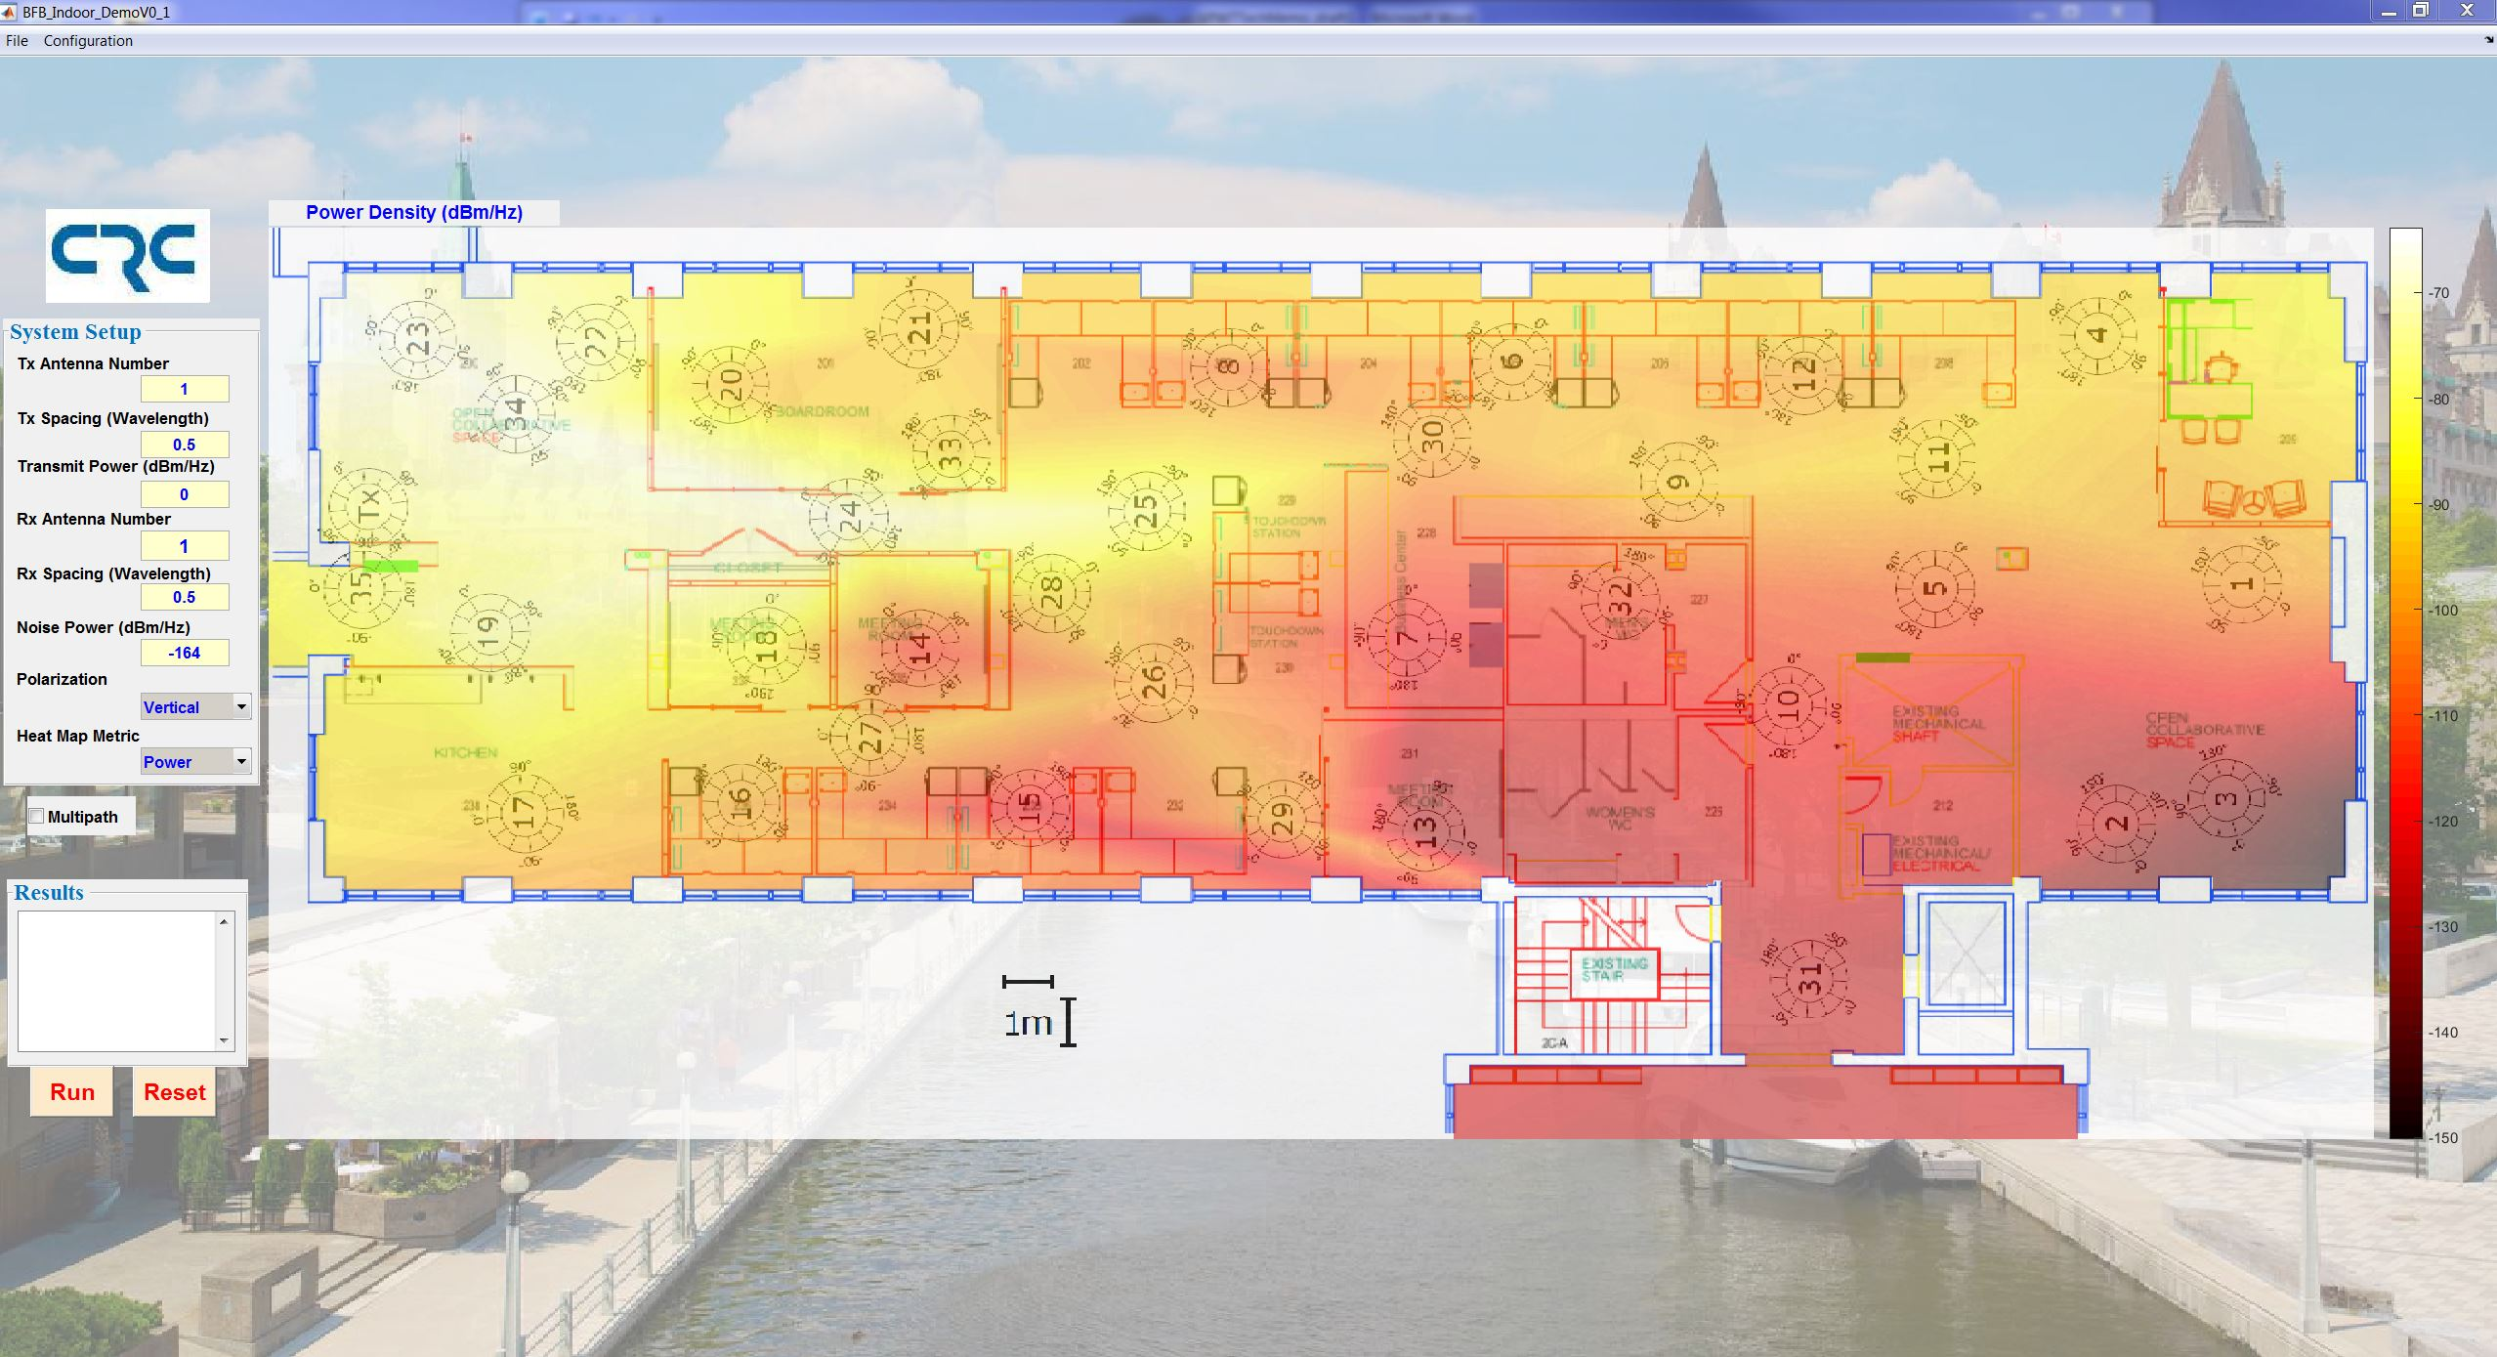

Figure 2.4: Layout of the graphic user interface.

# SYSTEM FUNCTIONALITIES

In the current development, we assume that both transmit and receive antennas use omni-directional antenna patterns. Without loss of generality, we also assume a 2-dimensional transmission in the horizontal plane. In the case of antenna arrays, the antenna arrays orients in a perpendicular fashion to the angular reference.

## GUI

The GUI consists of several components as shown in

* Menu (File/Configuration): The File menu provides an interface to select the map of floorplan to be investigated, and its associated measurement data file;

The Configuration menu provides an interface to input the transparent factor for multiple layer disaplay

* System Setup Panel: From this panel, can be configured as The parameters can be configured are listed in the following:
  + Tx Antenna Number: Number of antenna at transmitter.
  + Tx Spacing: Spacing between antennas at transmitter, which is normalized by wavelength
  + Transmitter Power: With unit of dBm/Hz
  + Rx Antenna Number: Number of antenna at receiver
  + Rx Spacing: Spacing between antennas at receiver, which is normalized by wavelength
  + Noise Power: Noise power at receiver with unit of dBm/Hz
  + Polarization: To select the type of polarization (vertical or horizontal)
  + Heat Map Metric. To select the metric to be displayed in the heat map panel (Power, SNR, or capacity)
* Options: Three extra options are provided.
  + Multipath: Enabled multipath checkbox will display the multipath of all measured location at the heatmap panel.
  + Improvement: When Improvement checkbox is enabled, the heatmap panel will display the capacity improvement of current system setup compared with SISO system.
  + Tx Antenna Sweep: Click this button, the received multipaths at all measured location will be displayed when transmitter with a directional pattern is employed.
* Results Panel: Show performance in numerical values where the heatmap is clicked.
* Heatmap Panel: The propagation characterization and system performance metrics will be displayed in this panel. The details about this panel are given in the following.

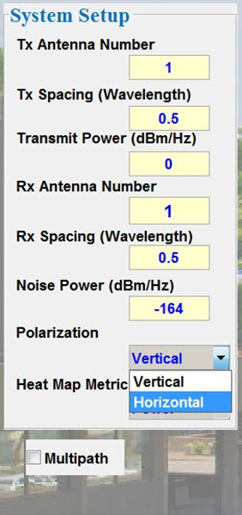 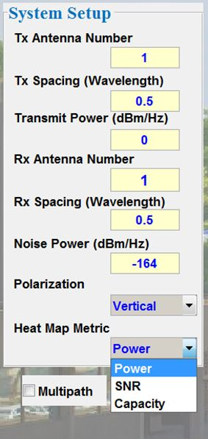 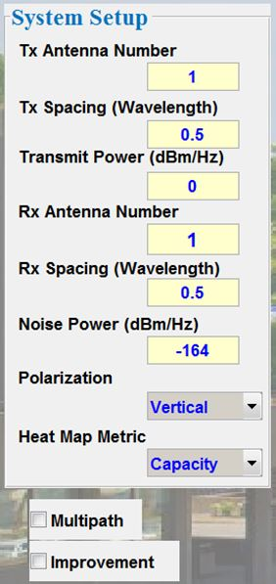

Figure 3.1: Functions of the control panel (need to update).

## Multipath Propagation Characterization

The propagation measurement is characterized by multipath propagation components (MPCs) at each measurement location. As mentioned in Section 2.1, each MPC is composed of AoD from the transmitter, the complex-valued path gain (or loss) from the transmitter to the receiver, and AoA at the receiver. At each measurement location, 1000 MPCs are produced and many of them are clustered together, as shown in Figure 2.1.

To demonstrate the multipath propagation characterization, the AoDs and AoAs are divided into several grids. The 1000 MPCs are clustered based on which grid they are located. In each cluster, the center and standard deviation of the AoD and AoD are calculated. Figure 3.2 shows the clustered AOD-AOA distribution for the MPCs shown in Figure 2.1.



Figure 3.2: Clustered AOD-AOA distribution, 26 GHz, Vertical polarization.

In this developed system, when the Multipath checkbox is enabled, six strongest MPC cluster at each receive location will be displayed, as shown in Figure 3.2. In the figure, each MPC cluster is represented by a fan shaped symbol pointing at the center of the receive location, and it indicates AoA of the multipath propagation component with its “width” representing one standard deviation of the angular spread, as well as the length representing the pathloss gain When any point in the heatmap panel is double clicked, the nearest receive location will be selected. The six MPC clusters for this specified receive location will be displayed. Meanwhile, the characteristics of these MPC clusters, mean and std of AoAs, mean and std of AoAs, and path loss, will be listed in the Result panel. One example is shown in Figure 3.4.

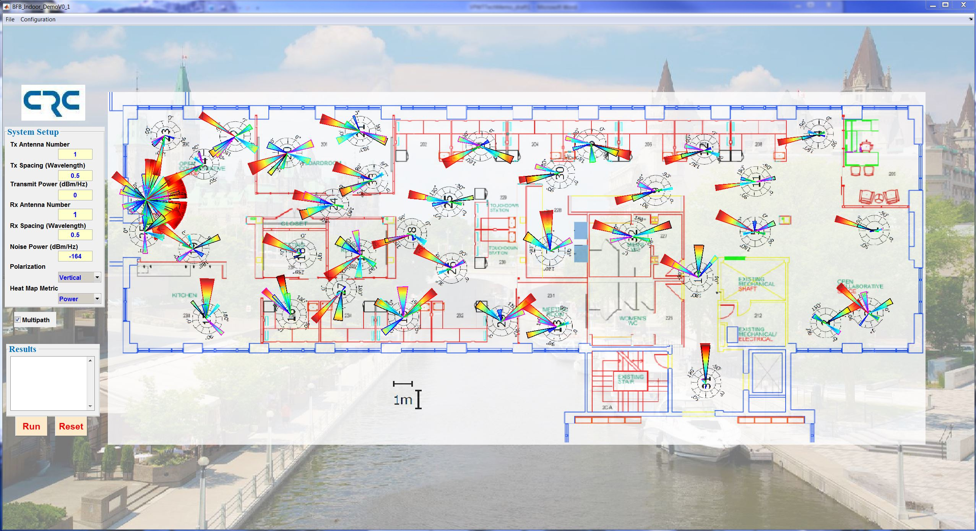

Figure 3.3: Start-up illustration of 6 strongest MPC clusters at all receive locations.

TODO

Figure 3.4: Illustration of 6 strongest MPC clusters at one receive location (update).

## Transmitter Antenna Sweep

When the Tx Antenna Sweep is clicked, the multipath propagation characteristics will be investigated when a directional antenna is employed in the transmitter. The antenna will sweep around one circle. When the antenna sweeps to cover one direction area, the multipath clusters, which can be received, will be displayed for all receive locations. During the sweeping, it can be paused when press shift + click left button, and continue by press any key or click any mouse button.

Figure 3.5 shows one example when the sweeping is paused in the middle. This feature can illustrate how the propagation characterization is when a directional antenna is employed in the transmitter. It can be further used to investigate the effect of a directional transmitter antenna on the communications system performance.

## Coverage Heat Map Calculation

When Power is selected in the Heatmap Metric, the heatmap panel will display the heat map of the received power. To achieved it, the received power at all receive locations is calculated from



where $P_{r}$ is the received power in dB/Hz, denotes the transmitted power in dB/Hz given in the system setup panel, and is the complex-valued gain of $i$-th MPC. With the’s in all receive locations, the heat map over all floor can then be obtained by performing the interpolation on this 2-D scattered data set. Here the linear method is used for the interpolation and extrapolation.

Figure 3.5 shows an example of coverage heat map. By right clicking anywhere inside the heatmap panel, the point will be marked by “X”, and the received power and pass loss gain at that point will be listed in the Result Panel. One example is shown in Figure 3.6.

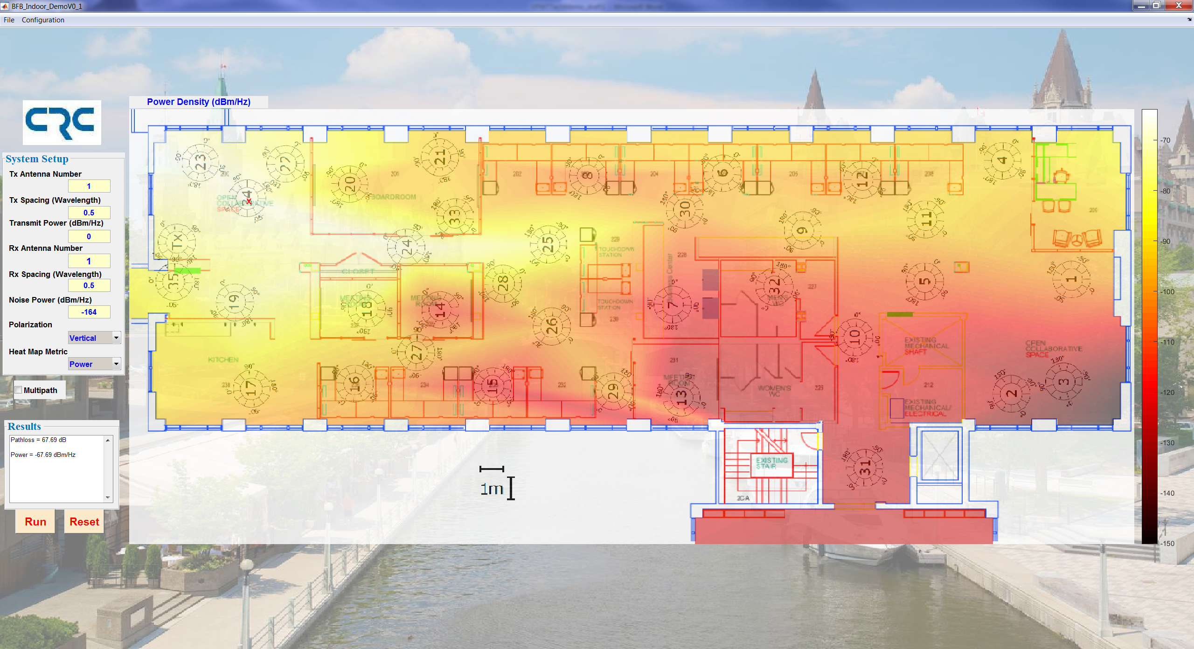

Figure 3.5: An example of coverage heat map, with Site#34 listed in the results window.

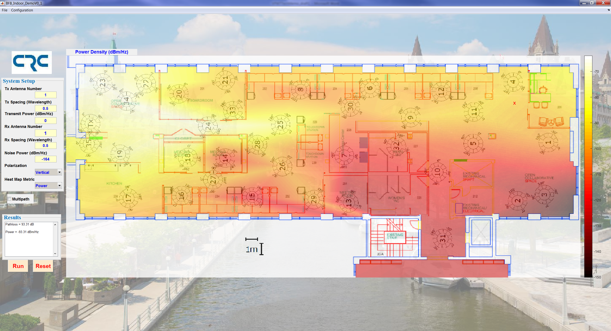

Figure 3.6: An example of coverage heat map, with values at a location marked by “x” near Site#4 listed in the results window.

## SNR Calculation

When SNR is selected in the Heatmap Metric, the heatmap panel will display the heat map of the SNR over whole area. Firstly, we calculate the SNR at the measurement location by



where is the received power in dB/Hz form Eq. (1) and $P_{t}$ is transmitted power in dB/Hz given in the system setup panel.

With the SNR’s in the measurement locations, the heat map over whole area can then be obtained by performing the interpolation on the 2-D scattered SNR data set. The linear method is used for the interpolation and extrapolation here. Figure 3.7 shows an example of SNR heat map. By right clicking anywhere inside the heatmap panel, the point will be marked by “X”, and the SNR and pass loss gain at that point will be listed in the Result Panel.

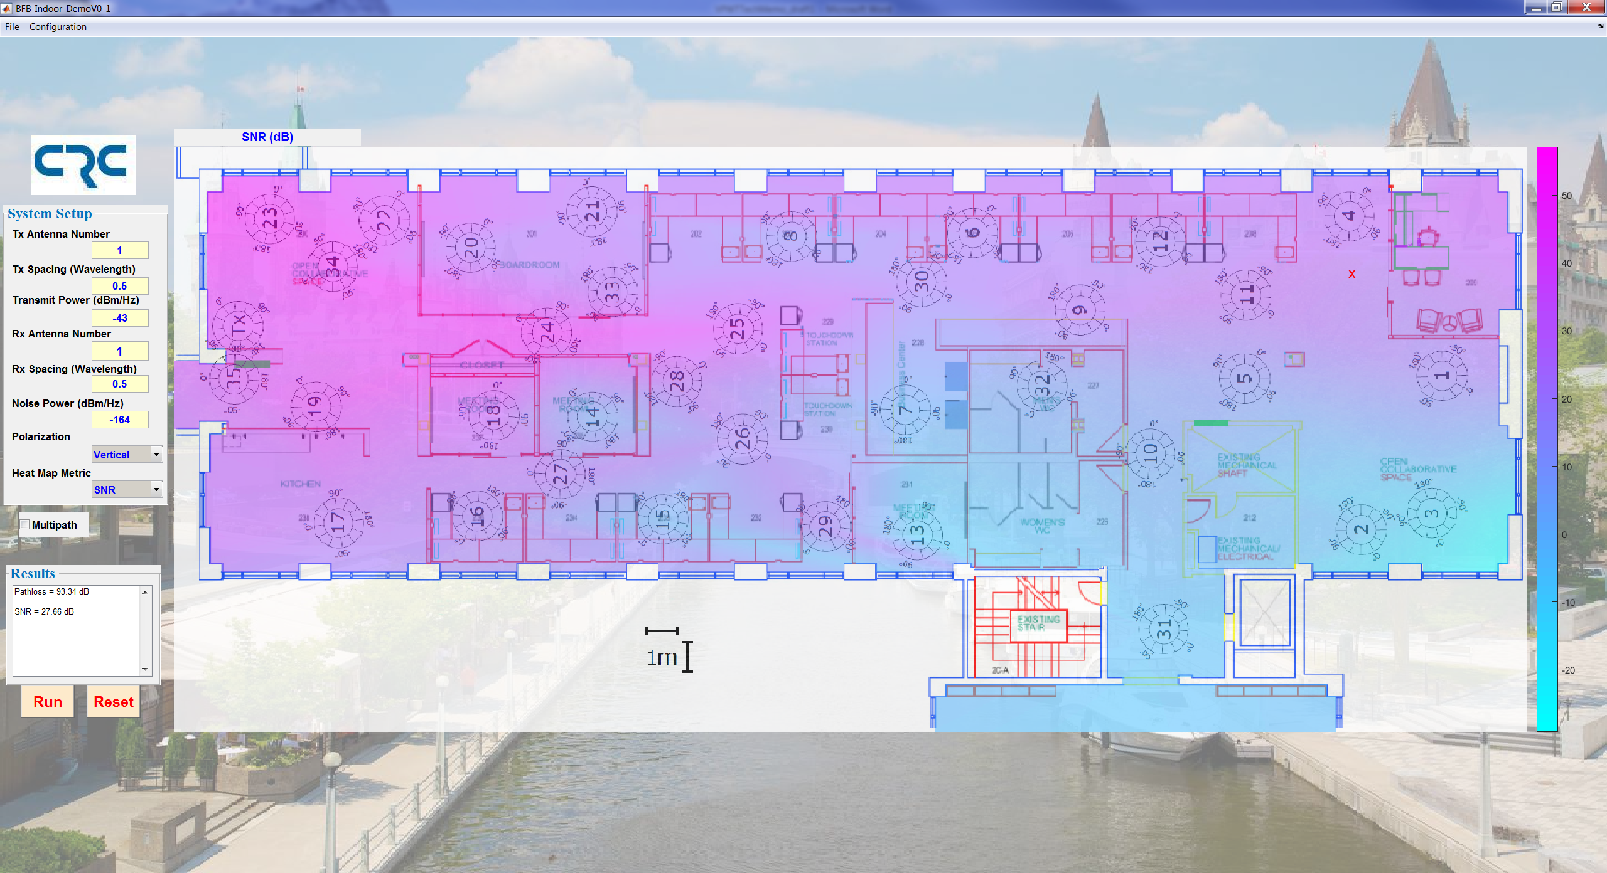

Figure 3.7: An example of SNR distribution map, with the value at a location marked by “x” near Site#4.

## Channel Capacity Calculation And Visualization

When Capacity is selected in the Heatmap Metric, the heatmap panel will display the heat map of the capacity over whole area. First, the capacity at the measurement location are calculated based on the Shannon channel capacity. In the following, the capacity of MIMO system is discussed, which can be easily applied to SISO,SIMO, and MISO system.

For a MIMO channel, the channel capacity is defined as follows:

 3

where “” is the total transmitted power out of the antenna array, $σ^{2}$ is the noise power. $H_{total}$ is the total channel state information matrix, including both transmit antenna patterns and receive antenna patterns, in addition to the multipath and scattering propagation environment. The function $det\left( \right)$ denotes the determinant of a square matrix. To simplify the notation, “*f*” in $H_{total}\left(f\right)$ is dropped in the notations from Equation (2) and forward.

With the capacity values in the measurement location, the capacity over whole area can then be obtained by performing the interpolation on the 2-D scattered capacity data. The linear method is used for the interpolation and extrapolation here.

Figure 3.8 shows an example of capacity heat map for SISO system. By right clicking anywhere inside the heatmap panel, the point will be marked by “X”, and the pass loss gain, SNR, and capacity at that point will be listed in the Result Panel.

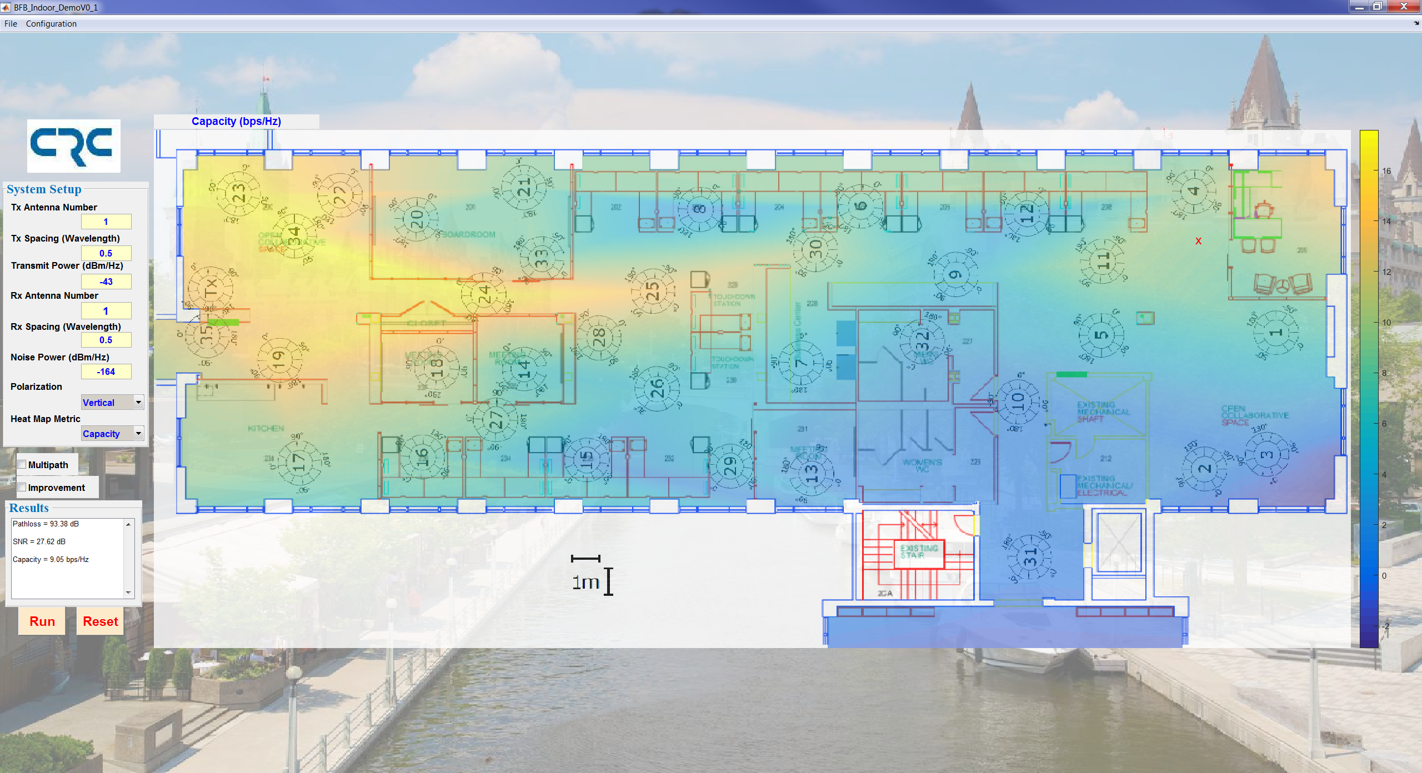

Figure 3.8: An example of SISO channel capacity distribution.

For the MISO, SIMO, and MIMO systems, the capacity improvement, compared to the SISO system, can be illustrated by enabling the “Improvement” button. Figures 3.9-3.11 show the examples of capacity and improvement heat map for an SIMO () system, an MISO ($4×1$), and an MIMO system (4 $×4$), respectively.

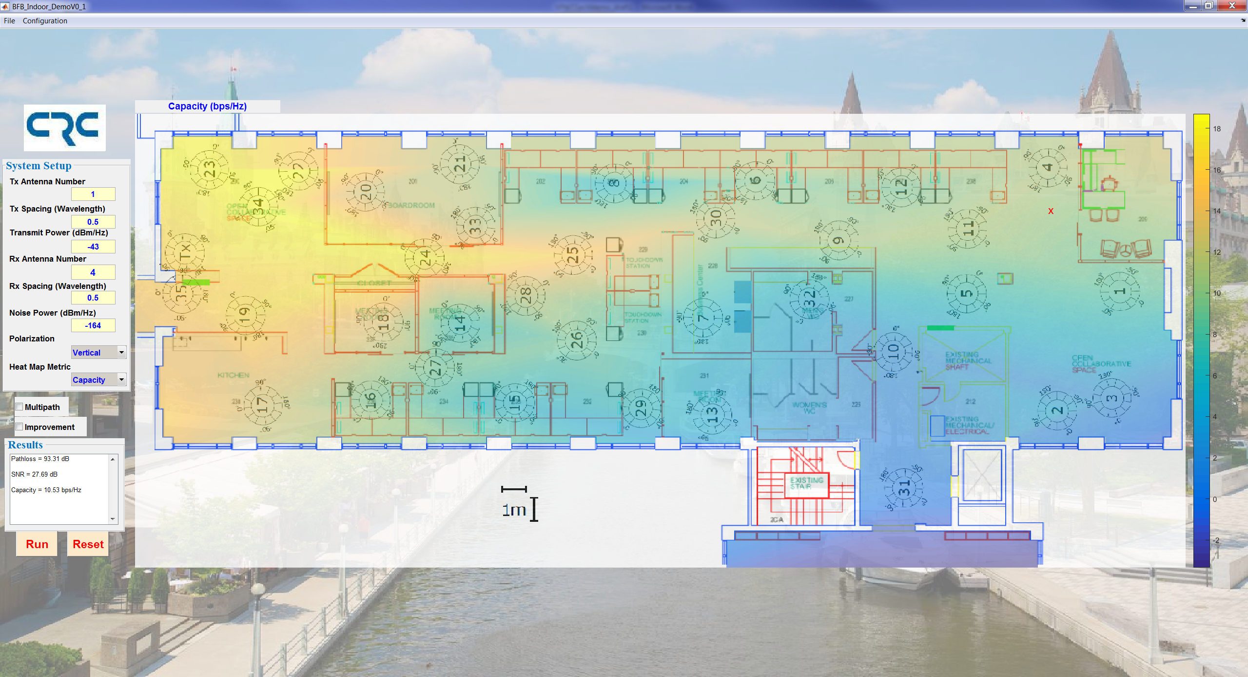

1. Capacity

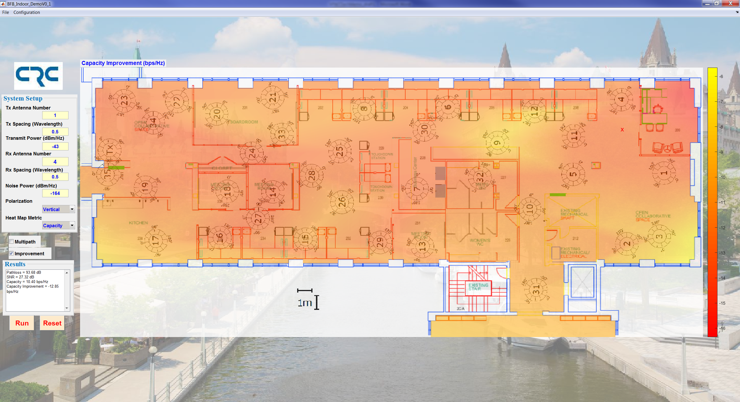

1. Capacity gain of SIMO over SISO (the result is not correct??)

Figure 3.9: An example of SIMO channel capacity distribution and improvements over SISO.

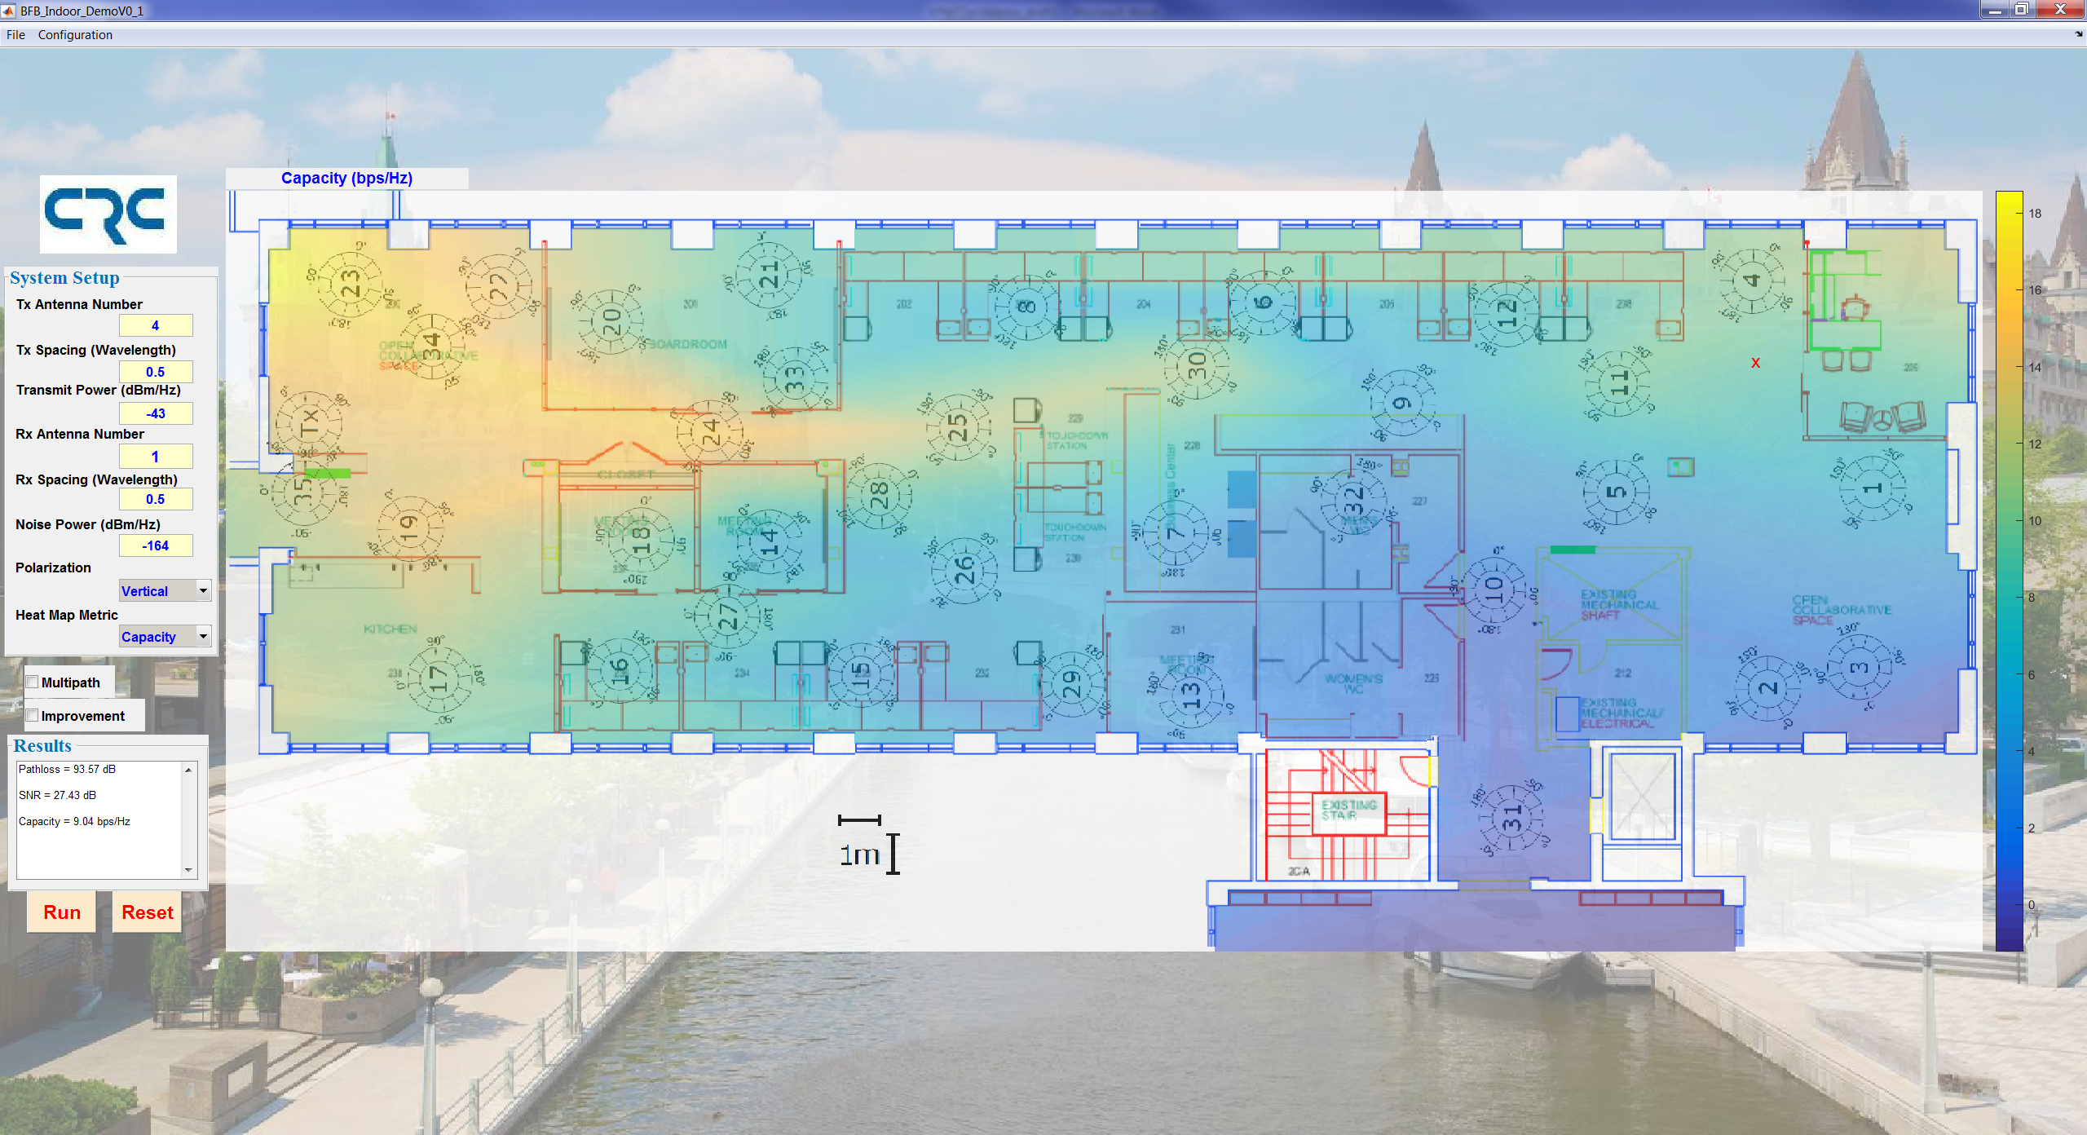(a) Capacity

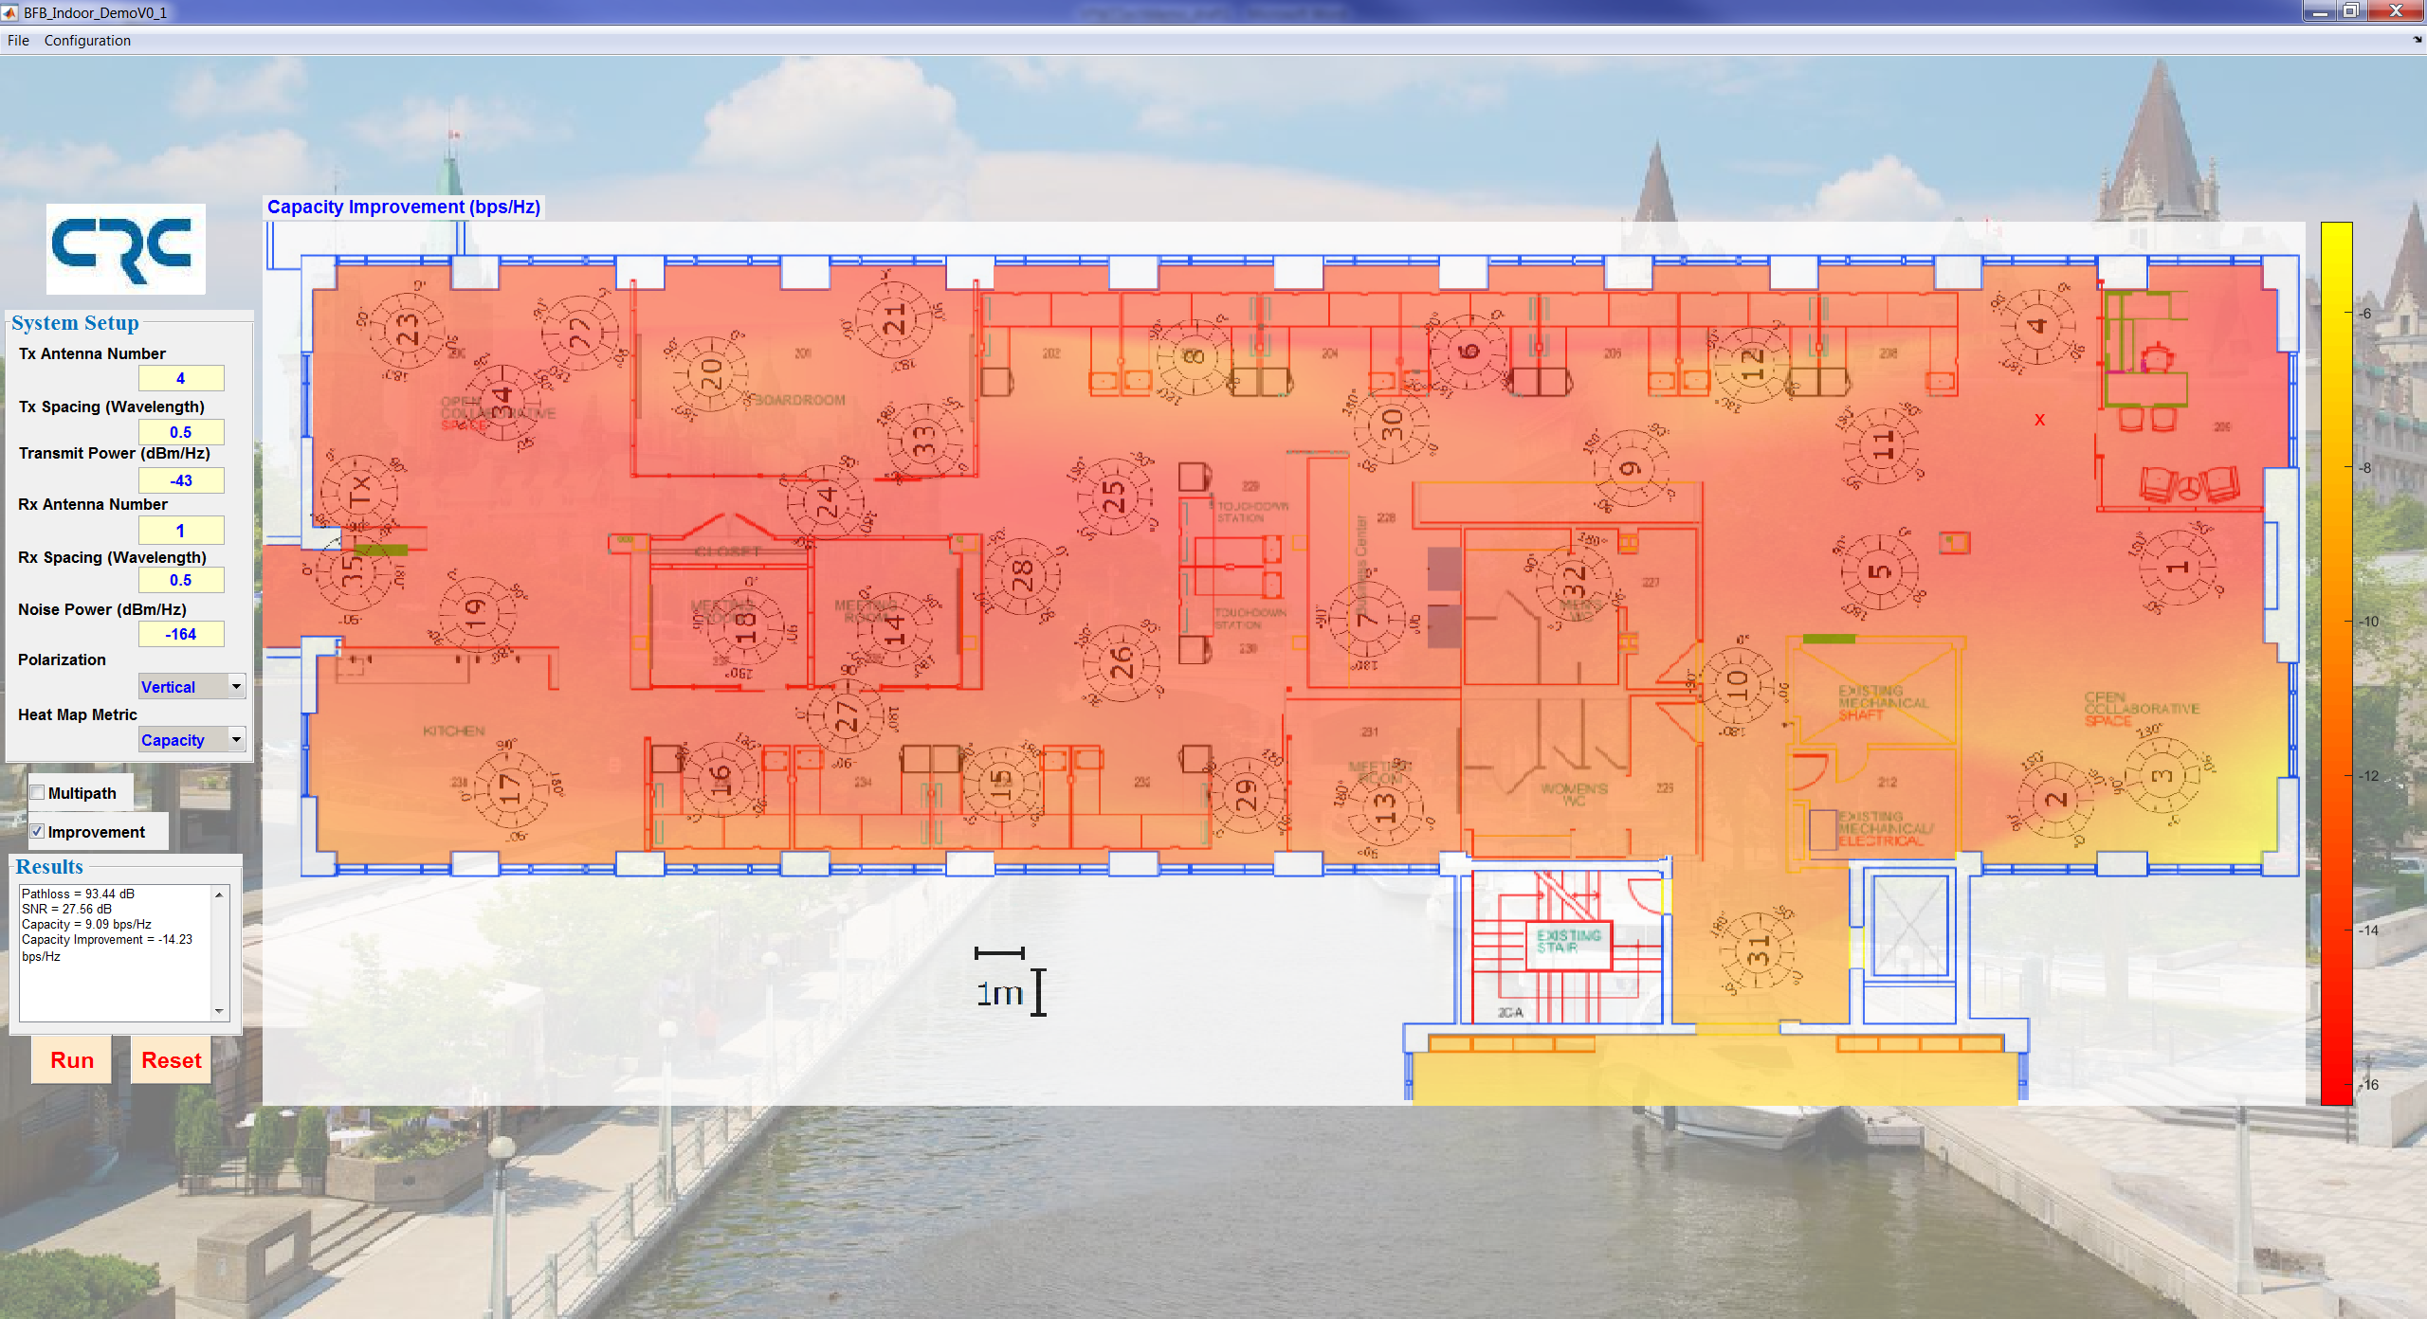

(b) Capacity improvement over SISO (the result is not right)

Figure 3.10: An example of MISO channel capacity distribution.

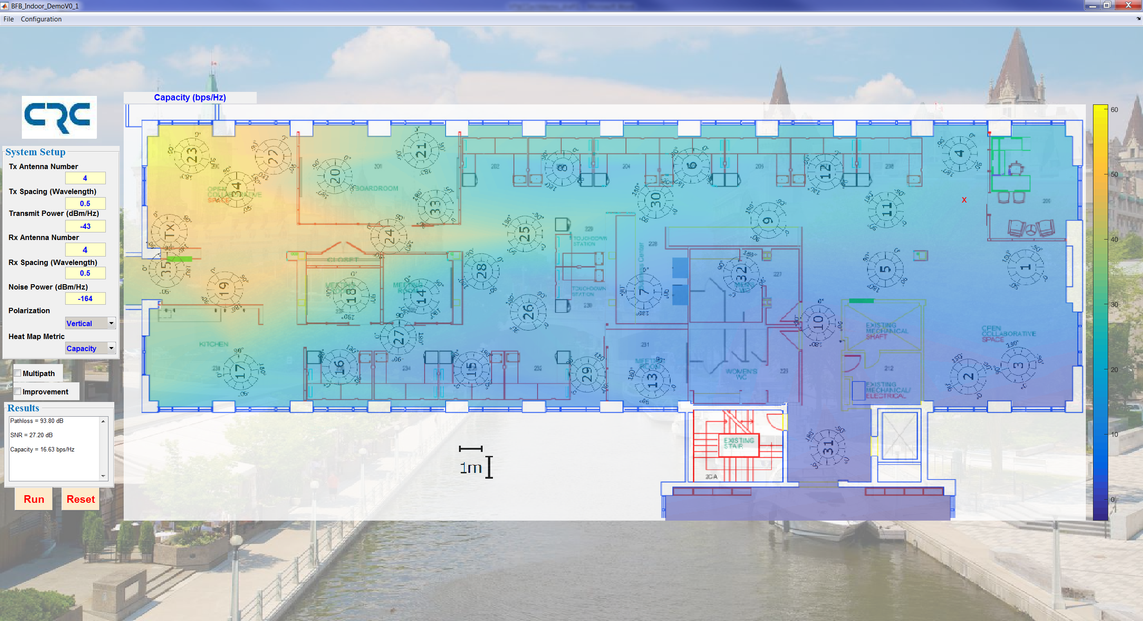

1. Capacity

(a)

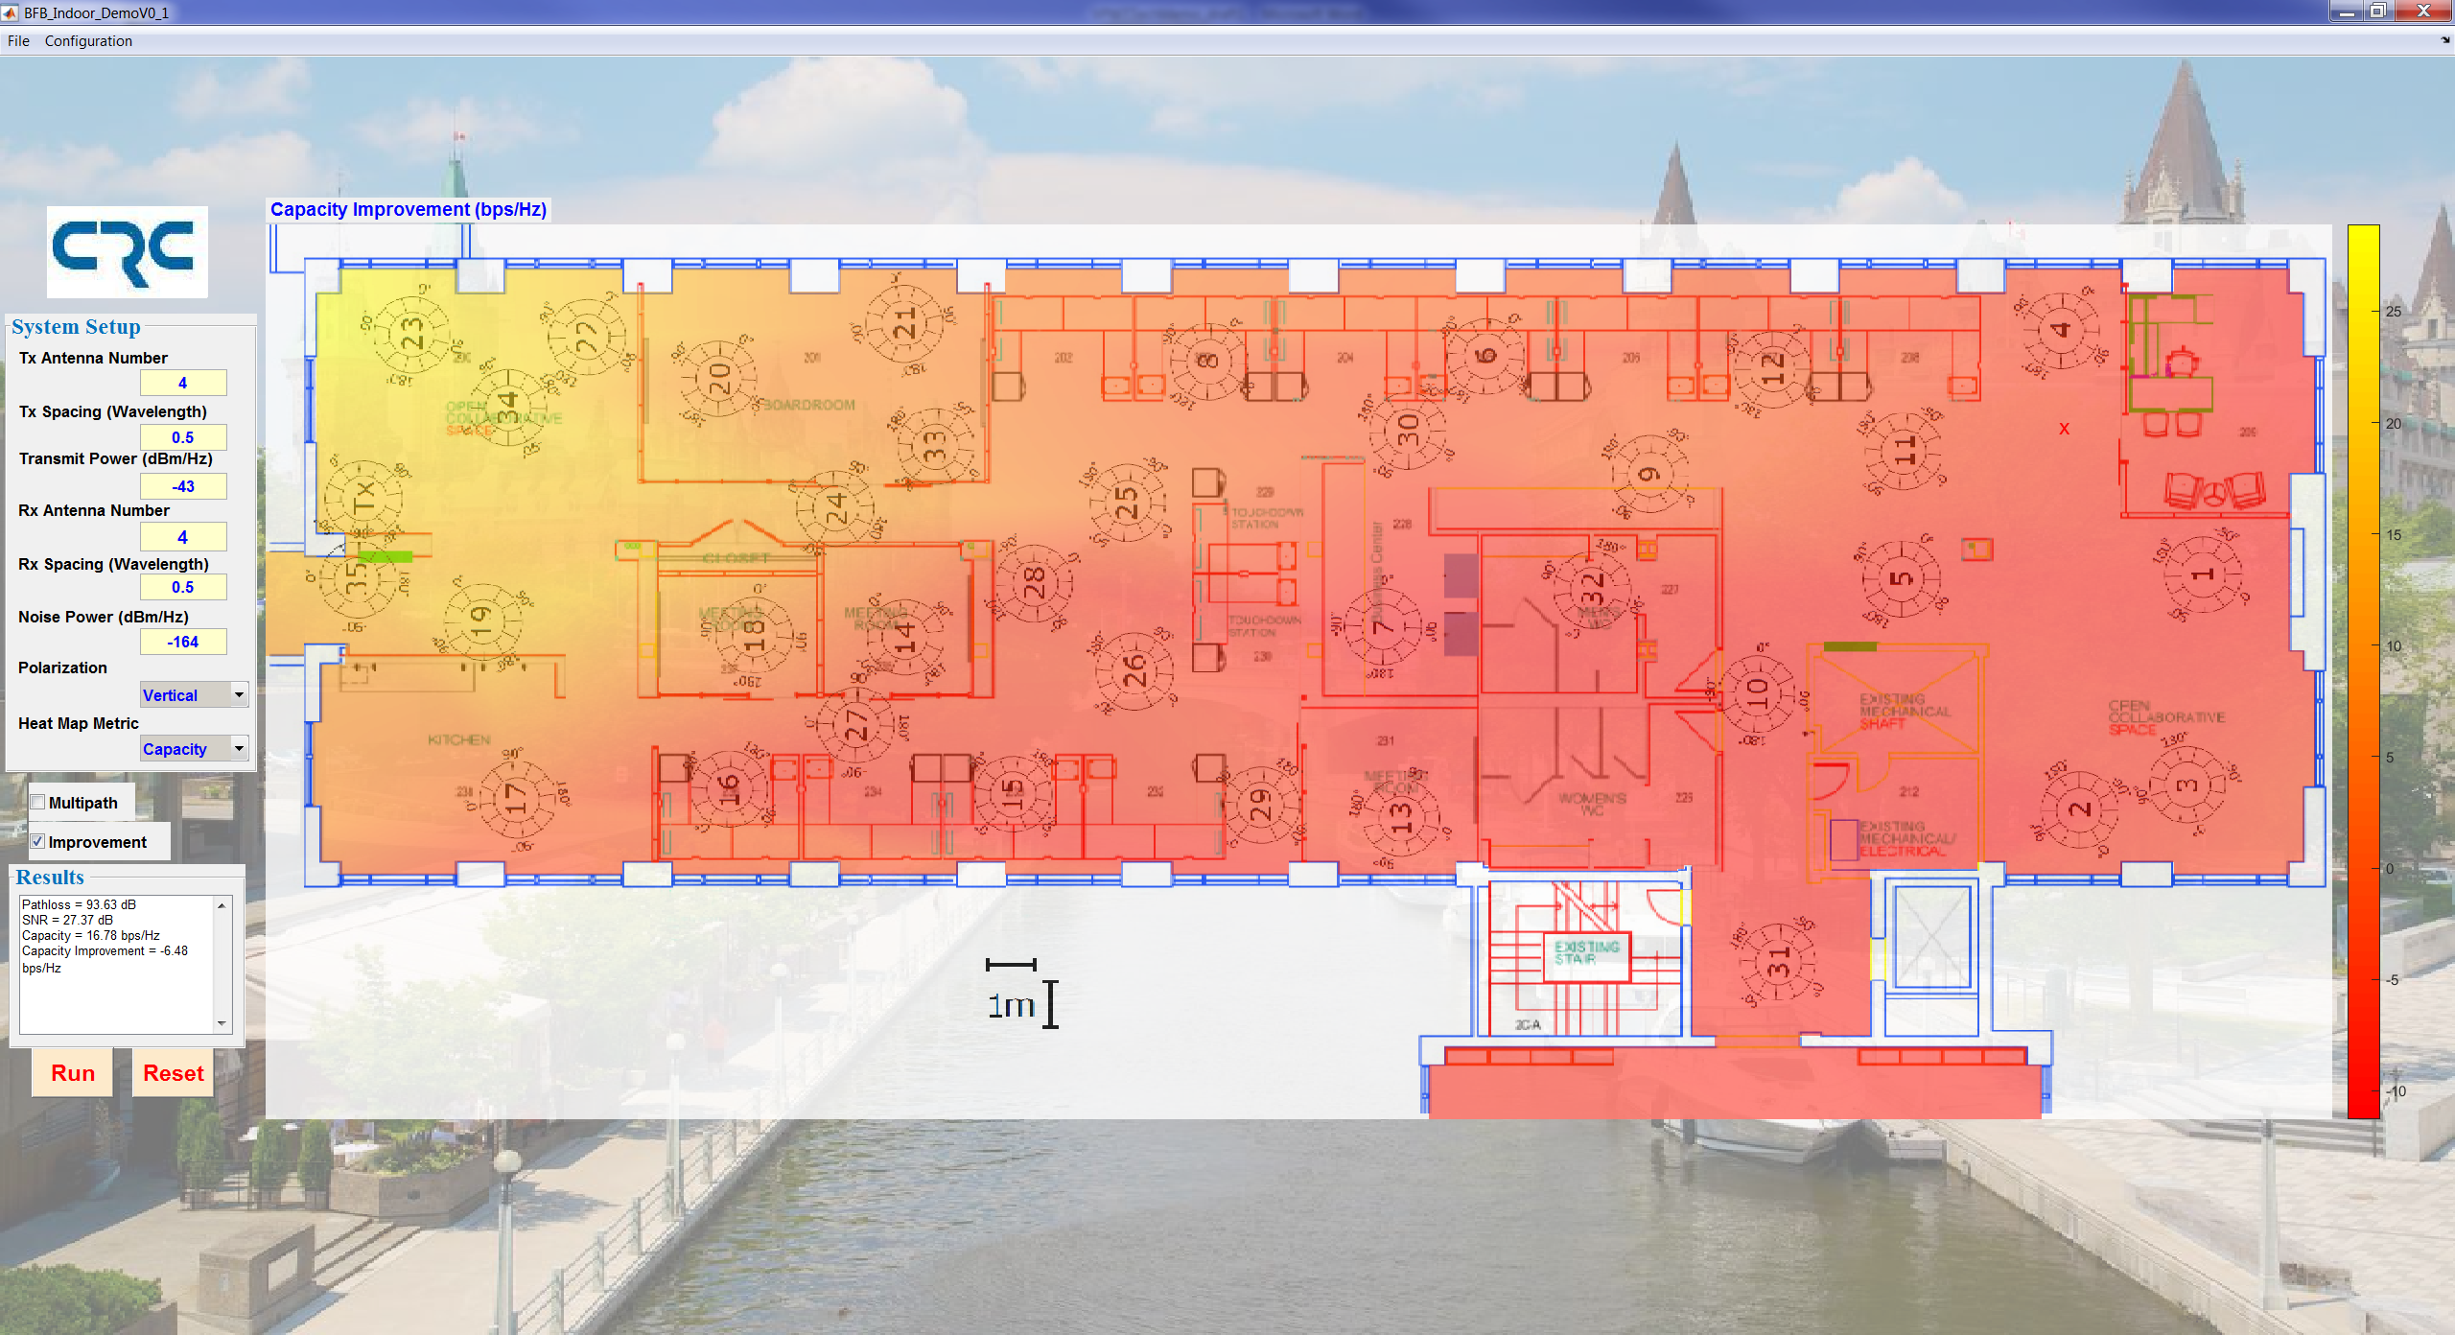

1. Capacity improvement over SISO

Figure 3.11: An example of channel capacity improvement of MIMO over SISO (the result is not right).

Table 1 lists the capacities of an and an 2 $×4$ MIMO system at several locations, as well as their corresponding improvements compared with the SISO system. The results tell us that different system configuration results in different performance even when the total antennas are the same.

Table 1. Capacity comparison of 4x2 and 2x4 MIMO Systems

|  |  |  |
| --- | --- | --- |
| Site Location | Capacity [ Improvement ](dB) | |
| MIMO | MIMO |
| 1 |  |  |
| 12 |  |  |
| 24 |  |  |
| 36 |  |  |

# FUTURE ENHANCEMENTs

A number of environments and performance metrics or indicators can be added to enhance the capability of the spatial agility assessment and visualization system.

## Antenna Characteristics

The current implementation is based on uniform linear array of omni-directional elements. It is planned to implement non-uniform arrays and 3-dimensional arrays of omni-directional elements in the next version of the spatial agility assessment and visualization system.

In addition, reconfigurable patterns will be implemented to assess and demonstrate their usefulness in the communication capacity enhancement.

## Ray-Tracing Model

In situations where the actual propagation measurement is not available or not sufficient, the simulated propagation information from the ray tracing tool may be used to predict the spatial agility capability. To this end, it is planned to incorporate the ray tracing simulation result in the future enhancement. The ray-tracing simulation not only can be used to fill the gap when the measurement is not available, but also can be used for comparative study to refine the simulation model.

## More User Cases

The current version only has the measurement result at the second floor of Building 2C. It is planned to include more user cases, such as the second floor of Building 2A at CRC, outdoor environment at Ottawa City Hall, etc.

## Spectrum Efficiency Assessment

The ultimate goal is to assess the spectrum efficiency. The channel capacity is only an indication of the up bound. To assess the spectrum efficiency of a given technology such as Wi-Fi or LTE system, it is planned to include such technologies to assess their actual throughputs against the channel capacity limit to derive the spectrum efficiency of these technologies.

## Array-based Propagation Measurement

The existing propagation measurement is conducted using a single channel propagation measurement setup. At mmWave frequency bands being considered for 5G communication applications, the single channel setup may not be able to effectively capture spatial domain information due to the very short wavelength. The plan is in place to develop the capability of using array-based mmWave channel sounding system. When available, the results of the array-based propagation measurement results will be incorporated into the spatial agility capability assessment system.

## Migration to Cloud Implementation for BDAC Demonstration

The last, but not the least, is to migrate the spatial agility capability assessment system to the cloud based implementation for the planned BDAC demonstration during the Summer of 2017.

# CONCLUSION

To be done.

The spatial agility capability assessment and visualization platform combines outputs of the propagation measurement project and the spatial agility project of CRC’s Break Frequency Barrier Grand Challenge program. Developed in Matlab, this platform provides us with a flexible research environment to visually examine and investigate propagation environments (heat map, multipath propagation), to explore the spatial agility gain, and to evaluate and quantify the communication system capability of SISO, SIMO, MISO and MIMO systems.

Potentially lead to the development of a CRC wireless emulation and evaluation platform to assess communication system capability of future systems such as 5G communication systems.

# References

1. Yvo de Jong, “Clean processing of measured 2-60 GHz propagation data”, VPWT Tech.Memo.#82/16, September 8, 2016
2. X. Huang, “Channel capacity-based performance indicators for spatial agility capability assessment”, VPWT Tech.Memo.#02/16, January 13, 2016
3. More?

# Appendix: Source Code

Matlab source code will be included here for the record.

function varargout = BFB_Indoor_DemoV1_0(varargin)  
%BFB_INDOOR_DEMOV1_0 M-filemenu for BFB_Indoor_DemoV1_0.fig  
% BFB_INDOOR_DEMOV1_0, by itself, creates a new BFB_INDOOR_DEMOV1_0 or raises the existing  
% singleton*.  
%  
% H = BFB_INDOOR_DEMOV1_0 returns the handle to a new BFB_INDOOR_DEMOV1_0 or the handle to  
% the existing singleton*.  
%  
% BFB_INDOOR_DEMOV1_0('Property','Value',...) creates a new BFB_INDOOR_DEMOV1_0 using the  
% given property value pairs. Unrecognized properties are passed via  
% varargin to BFB_Indoor_DemoV1_0_OpeningFcn. This calling syntax produces a  
% warning when there is an existing singleton*.  
%  
% BFB_INDOOR_DEMOV1_0('CALLBACK') and BFB_INDOOR_DEMOV1_0('CALLBACK',hObject,...) call the  
% local function named CALLBACK in BFB_INDOOR_DEMOV1_0.M with the given input  
% arguments.  
%  
% *See GUI Options on GUIDE's Tools menu. Choose "GUI allows only one  
% instance to resetbutton (singleton)".  
%  
% See also: GUIDE, GUIDATA, GUIHANDLES  
  
% Edit the above text to modify the response to help BFB_Indoor_DemoV1_0  
  
% Last Modified by GUIDE v2.5 08-Feb-2017 09:40:04  
  
% Begin initialization code - DO NOT EDIT  
gui_Singleton = 0;  
gui_State = struct('gui_Name', mfilename, ...  
 'gui_Singleton', gui_Singleton, ...  
 'gui_OpeningFcn', @BFB_Indoor_DemoV1_0_OpeningFcn, ...  
 'gui_OutputFcn', @BFB_Indoor_DemoV1_0_OutputFcn, ...  
 'gui_LayoutFcn', [], ...  
 'gui_Callback', []);  
if nargin && ischar(varargin{1})  
 gui_State.gui_Callback = str2func(varargin{1});  
end  
  
if nargout  
 [varargout{1:nargout}] = gui_mainfcn(gui_State, varargin{:});  
else  
 gui_mainfcn(gui_State, varargin{:});  
end  
% End initialization code - DO NOT EDIT  
  
return;  
  
% --- Executes just before BFB_Indoor_DemoV1_0 is made visible.  
function BFB_Indoor_DemoV1_0_OpeningFcn(hObject, eventdata, handles, varargin)  
% This function has no output args, see OutputFcn.  
% hObject handle to figure  
% eventdata reserved - to be defined in a future version of MATLAB  
% handles structure with handles and user data (see GUIDATA)  
% varargin unrecognized PropertyName/PropertyValue pairs from the  
% command line (see VARARGIN)  
  
% Choose default command line output for BFB_Indoor_DemoV1_0  
handles.output = hObject;  
  
handles.App.TxAntSpace = str2double(get(handles.TxAntSpace,'string'));  
handles.App.TxAntNum = str2double(get(handles.TxAntNum,'string'));  
handles.App.TxPower = str2double(get(handles.TxPow,'string'));  
  
handles.App.RxAntSpace = str2double(get(handles.RxAntSpace,'string'));  
handles.App.RxAntNum = str2double(get(handles.RxAntNum,'string'));  
  
handles.App.NoisePower = str2double(get(handles.NoisePower,'string'));  
  
IndexSelected = get(handles.PolarizationSelect,'Value');  
MetricsList = get(handles.PolarizationSelect,'String');  
handles.App.Polarization = MetricsList{IndexSelected};  
  
IndexSelected = get(handles.HMMSelect,'Value');  
MetricsList = get(handles.HMMSelect,'String');  
handles.App.Metrics = MetricsList{IndexSelected};  
  
handles.App.ImprovementCheckbox = 0;  
%handles.App.FloorPlanFile = 'C:\UserApplications\Research\WT\BFB\Visual\CRC2C2FloorPlan.png';  
%handles.App.DataFile = 'C:\UserApplications\Research\WT\BFB\Visual\CRC2C2Floor26GHz.mat';  
  
handles.App.ColorMapType = 'cool';  
handles.App.TransparentFactor = 0.5;  
  
%set(handles.RunButton,'Enable','on');  
  
% Update handles structure  
guidata(hObject, handles);  
  
% UIWAIT makes BFB_Indoor_DemoV1_0 wait for user response (see UIRESUME)  
% uiwait(handles.figure1);  
return;  
  
% --- Outputs from this function are returned to the command line.  
function varargout = BFB_Indoor_DemoV1_0_OutputFcn(hObject, eventdata, handles)  
% varargout cell array for returning output args (see VARARGOUT);  
% hObject handle to figure  
% eventdata reserved - to be defined in a future version of MATLAB  
% handles structure with handles and user data (see GUIDATA)  
  
% Get default command line output from handles structure  
varargout{1} = handles.output;  
  
set(handles.figure1, 'units','normalized','outerposition',[0 0.03 1 0.97]);  
handles.MainAxes = axes('units','normalized','position',[0 0 1 1]);  
uistack(handles.MainAxes,'bottom');  
img = imread('Ottawa.jpg');  
hi = imagesc([0 1],[0 1],img);  
set(handles.MainAxes,'handlevisibility','off','visible','off');  
set(hi,'alphadata',0.5)  
  
handles.ProjectTitle = text(0.5,0.05, ...  
 {'BFB / Spatial Agility Capability Assessment'}, ...  
 'Parent',handles.MainAxes, ...  
 'HorizontalAlignment', 'center', ...  
 'fontname','elephant',...  
 'Color','blue','fontunit','normalized','FontSize',0.04);  
  
%set(handles.ProjectTitle,'BackgroundColor',get(gcf,'BackgroundColor'));  
  
set(handles.TxAntNum,'enable', 'off');  
set(handles.TxAntSpace,'enable', 'off');  
set(handles.TxPow,'enable', 'off');  
set(handles.RxAntNum,'enable', 'off');  
set(handles.RxAntSpace,'enable', 'off');  
set(handles.NoisePower,'enable', 'off');  
set(handles.PolarizationSelect,'enable', 'off');  
set(handles.HMMSelect,'enable', 'off');  
set(handles.MultipathCheckbox,'enable', 'off');  
set(handles.ImprovementCheckbox,'enable', 'off');  
  
img = imread('logo_CRC.jpg');  
axes(handles.CRCLogoAxis);  
imagesc([0 1],[0 1],img)  
set(handles.CRCLogoAxis,'xtick',[],'ytick',[],'XColor',[1 1 1],'YColor',[1 1 1],'ZColor',[1 1 1]);  
  
axes(handles.HeatMapAxis)  
set(handles.HeatMapAxis,'units','normalized');  
axis('off');  
set(gca,'Ydir','reverse');  
set(gca,'xlim',[0 1],'ylim',[0 1]);  
hold('on');  
  
handles.ReminderText = text(0.2,0.5, ...  
 {'Please Select:'  
 ' '  
 ' Floor plan and measurement data files'}, ...  
 'Parent',handles.HeatMapAxis, ...  
 'HorizontalAlignment', 'left', ...  
 'fontname','elephant',...  
 'Color','red','fontunit','normalized','FontSize',0.06);  
  
  
for Idx = 1:4  
 set(handles.ReminderText,'color','yellow');  
 pause(0.1);  
 set(handles.ReminderText,'color','red');  
 pause(0.1)  
end  
guidata(hObject, handles);  
  
return;  
  
% --- Executes on button press in ResetButton.  
function ResetButton_Callback(hObject, eventdata, handles)  
% hObject handle to ResetButton (see GCBO)  
% eventdata reserved - to be defined in a future version of MATLAB  
% handles structure with handles and user data (see GUIDATA)  
  
closeGUI = handles.figure1; %handles.figure1 is the GUI figure  
guiPosition = get(handles.figure1,'Position'); %get the position of the GUI  
guiName = get(handles.figure1,'Name'); %get the name of the GUI  
eval(guiName) %call the GUI again  
close(closeGUI); %close the old GUI  
set(gcf,'Position',guiPosition); %set the position for the new GUI  
  
return;  
  
function TxAntNum_Callback(hObject, eventdata, handles)  
% hObject handle to TxAntNum (see GCBO)  
% eventdata reserved - to be defined in a future version of MATLAB  
% handles structure with handles and user data (see GUIDATA)  
  
% Hints: get(hObject,'String') returns contents of TxAntNum as text  
% str2double(get(hObject,'String')) returns contents of TxAntNum as a double  
  
AppCleanPlot(hObject);  
handles = guidata(hObject);  
  
handles.App.TxAntNum = str2double(get(hObject,'string'));  
  
guidata(hObject, handles);  
  
return;  
  
% --- Executes during object creation, after setting all properties.  
function TxAntNum_CreateFcn(hObject, eventdata, handles)  
% hObject handle to TxAntNum (see GCBO)  
% eventdata reserved - to be defined in a future version of MATLAB  
% handles empty - handles not created until after all CreateFcns called  
  
% Hint: edit controls usually have a white background on Windows.  
% See ISPC and COMPUTER.  
if ispc && isequal(get(hObject,'BackgroundColor'), get(0,'defaultUicontrolBackgroundColor'))  
 set(hObject,'BackgroundColor','white');  
end  
  
function TxAntSpace_Callback(hObject, eventdata, handles)  
% hObject handle to TxAntSpace (see GCBO)  
% eventdata reserved - to be defined in a future version of MATLAB  
% handles structure with handles and user data (see GUIDATA)  
  
% Hints: get(hObject,'String') returns contents of TxAntSpace as text  
% str2double(get(hObject,'String')) returns contents of TxAntSpace as a double  
  
AppCleanPlot(hObject);  
handles = guidata(hObject);  
  
handles.App.TxAntSpace = str2double(get(hObject,'string'));  
  
% Update handles structure  
guidata(hObject, handles);  
  
return;  
  
% --- Executes during object creation, after setting all properties.  
function TxAntSpace_CreateFcn(hObject, eventdata, handles)  
% hObject handle to TxAntSpace (see GCBO)  
% eventdata reserved - to be defined in a future version of MATLAB  
% handles empty - handles not created until after all CreateFcns called  
  
% Hint: edit controls usually have a white background on Windows.  
% See ISPC and COMPUTER.  
if ispc && isequal(get(hObject,'BackgroundColor'), get(0,'defaultUicontrolBackgroundColor'))  
 set(hObject,'BackgroundColor','white');  
end  
  
function TxPow_Callback(hObject, eventdata, handles)  
% hObject handle to TxPow (see GCBO)  
% eventdata reserved - to be defined in a future version of MATLAB  
% handles structure with handles and user data (see GUIDATA)  
  
AppCleanPlot(hObject);  
handles = guidata(hObject);  
  
handles.App.TxPower = str2double(get(hObject,'string'));  
  
guidata(hObject, handles);  
  
return;  
  
% --- Executes during object creation, after setting all properties.  
function TxPow_CreateFcn(hObject, eventdata, handles)  
% hObject handle to TxPow (see GCBO)  
% eventdata reserved - to be defined in a future version of MATLAB  
% handles empty - handles not created until after all CreateFcns called  
  
% Hint: edit controls usually have a white background on Windows.  
% See ISPC and COMPUTER.  
if ispc && isequal(get(hObject,'BackgroundColor'), get(0,'defaultUicontrolBackgroundColor'))  
 set(hObject,'BackgroundColor','white');  
end  
  
function RxAntNum_Callback(hObject, eventdata, handles)  
% hObject handle to RxAntNum (see GCBO)  
% eventdata reserved - to be defined in a future version of MATLAB  
% handles structure with handles and user data (see GUIDATA)  
  
AppCleanPlot(hObject);  
handles = guidata(hObject);  
  
handles.App.RxAntNum = str2double(get(hObject,'string'));  
  
guidata(hObject, handles);  
  
return;  
  
% --- Executes during object creation, after setting all properties.  
function RxAntNum_CreateFcn(hObject, eventdata, handles)  
% hObject handle to RxAntNum (see GCBO)  
% eventdata reserved - to be defined in a future version of MATLAB  
% handles empty - handles not created until after all CreateFcns called  
  
% Hint: edit controls usually have a white background on Windows.  
% See ISPC and COMPUTER.  
if ispc && isequal(get(hObject,'BackgroundColor'), get(0,'defaultUicontrolBackgroundColor'))  
 set(hObject,'BackgroundColor','white');  
end  
  
function RxAntSpace_Callback(hObject, eventdata, handles)  
% hObject handle to RxAntSpace (see GCBO)  
% eventdata reserved - to be defined in a future version of MATLAB  
% handles structure with handles and user data (see GUIDATA)  
  
AppCleanPlot(hObject);  
handles = guidata(hObject);  
  
handles.App.RxAntSpace = str2double(get(hObject,'string'));  
  
guidata(hObject, handles);  
  
return;  
  
% --- Executes during object creation, after setting all properties.  
function RxAntSpace_CreateFcn(hObject, eventdata, handles)  
% hObject handle to RxAntSpace (see GCBO)  
% eventdata reserved - to be defined in a future version of MATLAB  
% handles empty - handles not created until after all CreateFcns called  
  
% Hint: edit controls usually have a white background on Windows.  
% See ISPC and COMPUTER.  
if ispc && isequal(get(hObject,'BackgroundColor'), get(0,'defaultUicontrolBackgroundColor'))  
 set(hObject,'BackgroundColor','white');  
end  
  
% --- Executes on selection change in HMMSelect.  
function HMMSelect_Callback(hObject, eventdata, handles)  
% hObject handle to HMMSelect (see GCBO)  
% eventdata reserved - to be defined in a future version of MATLAB  
% handles structure with handles and user data (see GUIDATA)  
  
AppCleanPlot(hObject);  
handles = guidata(hObject);  
  
IndexSelected = get(hObject,'Value');  
MetricsList = get(hObject,'String');  
if strcmp(handles.App.Metrics,MetricsList{IndexSelected}) == 1  
 return;  
end  
  
handles.App.Metrics = MetricsList{IndexSelected};  
if IndexSelected < 3  
 set(handles.TxAntNum,'string','1');  
 handles.App.TxAntNum = 1;  
 set(handles.RxAntNum,'string','1');  
 handles.App.RxAntNum = 1;  
 set(handles.ImprovementCheckbox,'visible','off');  
else  
 set(handles.ImprovementCheckbox,'visible','on');  
end  
guidata(hObject, handles);  
  
return;  
  
% --- Executes during object creation, after setting all properties.  
function HMMSelect_CreateFcn(hObject, eventdata, handles)  
% hObject handle to HMMSelect (see GCBO)  
% eventdata reserved - to be defined in a future version of MATLAB  
% handles empty - handles not created until after all CreateFcns called  
  
% Hint: listbox controls usually have a white background on Windows.  
% See ISPC and COMPUTER.  
if ispc && isequal(get(hObject,'BackgroundColor'), get(0,'defaultUicontrolBackgroundColor'))  
 set(hObject,'BackgroundColor','white');  
end  
  
function ResultsWindow_Callback(hObject, eventdata, handles)  
% hObject handle to ResultsWindow (see GCBO)  
% eventdata reserved - to be defined in a future version of MATLAB  
% handles structure with handles and user data (see GUIDATA)  
  
% Hints: get(hObject,'String') returns contents of ResultsWindow as text  
% str2double(get(hObject,'String')) returns contents of ResultsWindow as a double  
return;  
  
% --- Executes during object creation, after setting all properties.  
function ResultsWindow_CreateFcn(hObject, eventdata, handles)  
% hObject handle to ResultsWindow (see GCBO)  
% eventdata reserved - to be defined in a future version of MATLAB  
% handles empty - handles not created until after all CreateFcns called  
  
% Hint: edit controls usually have a white background on Windows.  
% See ISPC and COMPUTER.  
if ispc && isequal(get(hObject,'BackgroundColor'), get(0,'defaultUicontrolBackgroundColor'))  
 set(hObject,'BackgroundColor','white');  
end  
  
% --------------------------------------------------------------------  
function FileMenu_Callback(hObject, eventdata, handles)  
% hObject handle to FileMenu (see GCBO)  
% eventdata reserved - to be defined in a future version of MATLAB  
% handles structure with handles and user data (see GUIDATA)  
return;  
  
% --------------------------------------------------------------------  
function FloorPlanSelect_Callback(hObject, eventdata, handles)  
% hObject handle to FloorPlanSelect (see GCBO)  
% eventdata reserved - to be defined in a future version of MATLAB  
% handles structure with handles and user data (see GUIDATA)  
  
AppCleanPlot(hObject);  
handles = guidata(hObject);  
  
while 1  
 [FileStr,PathStr] = uigetfile(...  
 { '*.gif;*.;*.png;*.tif;*.bmp;**.jpg','Figure (*.gif,*.png,*.tif ...)'; ...  
 '*.*', 'All Files (*.*)'}, ...  
 'Select Floor Plan ');  
  
 if FileStr == 0  
 return;  
 else  
 break;  
 end  
end  
  
img = imread(strcat(PathStr,FileStr));  
[PathStr,FileNameStr,~] = fileparts(strcat(PathStr,FileStr));  
  
cla(handles.HeatMapAxis);  
axes(handles.HeatMapAxis);  
handles.App.CBhandle = colorbar;  
set(handles.App.CBhandle,'visible','off')  
  
handles.App.FloorMapHandle = imagesc([0 1],[0 1],img, ...  
 'ButtonDownFcn',@(Src, Evt)AppResultDisplayCallback(Src,Evt,hObject,handles));  
set(handles.App.FloorMapHandle,'alphadata',0.8)  
drawnow  
hold on  
  
  
% t2 = get(handles.HeatMapAxis,'position');  
% axis square  
%  
% [y1,x1,~] = size(img);  
% t1 = get(0,'screensize');  
%  
% RatioAxis = y1/x1;  
%  
% if RatioAxis > 1  
% set(handles.HeatMapAxis,'position',[t2(1) t2(2) t2(3)/RatioAxis t2(4)]);  
% else  
% set(handles.HeatMapAxis,'position',[t2(1) t2(2) t2(3) t2(4)*RatioAxis]);  
% end  
% t21 = get(handles.HeatMapAxis,'position');  
% set(handles.HeatMapAxis,'position',[t2(1) t2(2) t21(3)*t1(3)/t1(4) t21(4)]);  
  
handles.App.FloorPlanFile = fullfile(PathStr,FileStr);  
handles.App.FloorMaskFile = fullfile(PathStr, [FileNameStr '.mat']);  
  
set(handles.HeatMapAxis,'xtick',[],'ytick',[], ...  
 'XColor',[1 1 1],'YColor',[1 1 1],'ZColor',[1 1 1]);  
  
while 1  
 [FileStr,PathStr] = uigetfile(...  
 { '*.mat','MAT -file (*.mat)'; ...  
 '*.*', 'All Files (*.*)'}, ...  
 'Select Measurement Data File');  
  
 if FileStr == 0  
 return;  
 else  
 break;  
 end  
end  
  
handles.App.DataFile = fullfile(PathStr,FileStr);  
handles.App = MIMOperformanceAnalyzer(handles.App);  
%handles.App.CapacityBenchMark = handles.App.SiteCapacity;  
  
set(handles.TxAntNum,'enable', 'on');  
set(handles.TxAntSpace,'enable', 'on');  
set(handles.TxPow,'enable', 'on');  
set(handles.RxAntNum,'enable', 'on');  
set(handles.RxAntSpace,'enable', 'on');  
set(handles.NoisePower,'enable', 'on');  
set(handles.PolarizationSelect,'enable', 'on');  
set(handles.HMMSelect,'enable', 'on');  
set(handles.MultipathCheckbox,'enable', 'on');  
set(handles.ImprovementCheckbox,'enable', 'on');  
  
guidata(hObject, handles);  
AppDisplayMultipath(hObject);  
handles = guidata(hObject);  
  
set(handles.RunButton,'Enable','on');  
delete(handles.ReminderText);  
  
guidata(hObject, handles);  
  
return;  
  
% --- Executes on selection change in PolarizationSelect.  
function PolarizationSelect_Callback(hObject, eventdata, handles)  
% hObject handle to PolarizationSelect (see GCBO)  
% eventdata reserved - to be defined in a future version of MATLAB  
% handles structure with handles and user data (see GUIDATA)  
  
AppCleanPlot(hObject);  
handles = guidata(hObject);  
  
IndexSelected = get(hObject,'Value');  
MetricsList = get(hObject,'String');  
if strcmp(handles.App.Polarization,MetricsList{IndexSelected}) == 1  
 return;  
end  
  
handles.App.Polarization = MetricsList{IndexSelected};  
  
% Update handles structure  
guidata(hObject, handles);  
  
return;  
  
% --- Executes during object creation, after setting all properties.  
function PolarizationSelect_CreateFcn(hObject, eventdata, handles)  
% hObject handle to PolarizationSelect (see GCBO)  
% eventdata reserved - to be defined in a future version of MATLAB  
% handles empty - handles not created until after all CreateFcns called  
  
% Hint: listbox controls usually have a white background on Windows.  
% See ISPC and COMPUTER.  
if ispc && isequal(get(hObject,'BackgroundColor'), get(0,'defaultUicontrolBackgroundColor'))  
 set(hObject,'BackgroundColor','white');  
end  
  
function NoisePower_Callback(hObject, eventdata, handles)  
% hObject handle to NoisePower (see GCBO)  
% eventdata reserved - to be defined in a future version of MATLAB  
% handles structure with handles and user data (see GUIDATA)  
  
AppCleanPlot(hObject);  
handles = guidata(hObject);  
  
handles.App.NoisePower = str2double(get(hObject,'string'));  
guidata(hObject, handles);  
return;  
  
% --- Executes during object creation, after setting all properties.  
function NoisePower_CreateFcn(hObject, eventdata, handles)  
% hObject handle to NoisePower (see GCBO)  
% eventdata reserved - to be defined in a future version of MATLAB  
% handles empty - handles not created until after all CreateFcns called  
  
% Hint: edit controls usually have a white background on Windows.  
% See ISPC and COMPUTER.  
if ispc && isequal(get(hObject,'BackgroundColor'), get(0,'defaultUicontrolBackgroundColor'))  
 set(hObject,'BackgroundColor','white');  
end  
  
% --- Executes on button press in RunButton.  
function RunButton_Callback(hObject, eventdata, handles)  
% hObject handle to RunButton (see GCBO)  
% eventdata reserved - to be defined in a future version of MATLAB  
% handles structure with handles and user data (see GUIDATA)  
  
AppDisableGUI(hObject);  
AppCleanPlot(hObject);  
AppMetricCal(hObject);  
AppHeatMapPlot(hObject);  
AppEnableGUI(hObject);  
return;  
  
% --------------------------------------------------------------------  
function ConfigurationMenu_Callback(hObject, eventdata, handles)  
% hObject handle to ConfigurationMenu (see GCBO)  
% eventdata reserved - to be defined in a future version of MATLAB  
% handles structure with handles and user data (see GUIDATA)  
  
return;  
  
% --------------------------------------------------------------------  
function TransparentFactorSubMenu_Callback(hObject, eventdata, handles)  
% hObject handle to TransparentFactorSubMenu (see GCBO)  
% eventdata reserved - to be defined in a future version of MATLAB  
% handles structure with handles and user data (see GUIDATA)  
  
% TFList = {'0.1','0.2','0.3','0.4','0.5','0.6','0.7','0.8','0.9','1.0'};  
% [SelectedIdx,Flag] = listdlg('PromptString','Select tramsparent factor:',...  
% 'SelectionMode','single',...  
% 'ListString',TFList);  
  
prompt={'Enter Transparent Factor [0 1]:'};  
dlg_title = 'Transparent Factor';  
num_lines = 1;  
def = {'0.5'};  
TF = inputdlg(prompt,dlg_title,num_lines,def);  
  
if ~isempty(TF)  
 TF = str2double(TF);  
 if TF >= 0 && TF <= 1  
 handles.App.TransparentFactor = TF;  
 guidata(hObject,handles);  
 AppCleanPlot(hObject);  
 handles = guidata(hObject);  
 end  
end  
  
guidata(hObject, handles);  
return;  
  
% --- Executes on button press in ImprovementCheckbox.  
function ImprovementCheckbox_Callback(hObject, eventdata, handles)  
% hObject handle to ImprovementCheckbox (see GCBO)  
% eventdata reserved - to be defined in a future version of MATLAB  
% handles structure with handles and user data (see GUIDATA)  
  
% Hint: get(hObject,'Value') returns toggle state of ImprovementCheckbox  
  
AppCleanPlot(hObject);  
handles = guidata(hObject);  
  
handles.App.ImprovementCheckbox = get(hObject,'Value');  
guidata(hObject, handles);  
  
return;  
  
function AppMetricCal(hObject)  
  
handles = guidata(hObject);  
  
load(handles.App.FloorMaskFile);  
[Xq,Yq] = meshgrid(0.0005:0.001:1, 0.001:0.002:1);  
[Ynm,Xnm] = size(CRCMapping);  
[Xg,Yg] = meshgrid((0:Xnm-1)/(Xnm-1), (0:Ynm-1)/Ynm);  
CRCMapping(CRCMapping == 0) = NaN;  
FloorPlanMasking = interp2(Xg,Yg,CRCMapping,Xq,Yq,'linear');  
  
handles.App = MIMOperformanceAnalyzer(handles.App);  
MeasureMetrics = [handles.App.SitePowerdensity handles.App.SiteSNR handles.App.SiteCapacity];  
for Idx = 1:3  
 F1 = scatteredInterpolant(handles.App.Rxpositions(:,1),handles.App.Rxpositions(:,2),MeasureMetrics(:,Idx));  
 handles.App.PlotMetricData(:,:,Idx) = F1(Xq,Yq).*FloorPlanMasking;  
end  
  
if handles.App.ImprovementCheckbox == 1 && strcmpi(handles.App.Metrics,'capacity') == 1  
 F1 = scatteredInterpolant(handles.App.Rxpositions(:,1),handles.App.Rxpositions(:,2),...  
 MeasureMetrics(:,3) - handles.App.CapacityBenchMark);  
 handles.App.PlotDeltaMetricData = F1(Xq,Yq).*FloorPlanMasking;  
end  
guidata(hObject,handles);  
return;  
  
function AppHeatMapPlot(hObject)  
  
handles = guidata(hObject);  
axes(handles.HeatMapAxis);  
switch(lower(handles.App.Metrics))  
 case 'power'  
 MetricData = handles.App.PlotMetricData(:,:,1);  
 handles.App.ColorMapType = 'hot';  
 set(handles.HeatMapText,'visible','on')  
 set(handles.HeatMapText,'string','Power Density (dBm/Hz)');  
 case 'snr'  
 MetricData = handles.App.PlotMetricData(:,:,2);  
 handles.App.ColorMapType = 'cool';  
 set(handles.HeatMapText,'visible','on')  
 set(handles.HeatMapText,'string','SNR (dB)');  
 case 'capacity'  
 if handles.App.ImprovementCheckbox == 0  
 MetricData = handles.App.PlotMetricData(:,:,3);  
 handles.App.ColorMapType = 'parula';  
 set(handles.HeatMapText,'visible','on')  
 set(handles.HeatMapText,'string','Capacity (bps/Hz)');  
 else  
 MetricData = handles.App.PlotDeltaMetricData;  
 handles.App.ColorMapType = 'autumn';  
 set(handles.HeatMapText,'visible','on')  
 set(handles.HeatMapText,'string','Capacity Improvement (bps/Hz)');  
 end  
end  
  
TransparentFactor = handles.App.TransparentFactor;  
colormap(handles.HeatMapAxis,handles.App.ColorMapType);  
  
set(handles.HeatMapAxis,'color','none','xtick',[],'ytick',[], ...  
 'XColor',[1 1 1],'YColor',[1 1 1],'ZColor',[1 1 1]);  
  
CBhandle = handles.App.CBhandle;  
  
set(CBhandle,'visible','on')  
HMHandle = imagesc([0 1],[0 1],MetricData, ...  
 'ButtonDownFcn',@(Src, Evt)AppResultDisplayCallback(Src,Evt,hObject,handles));  
  
set(HMHandle,'alphadata',~isnan(MetricData)*TransparentFactor)  
drawnow  
  
% Make the colorbar transparent  
cdata = CBhandle.Face.Texture.CData;  
cdata(end,:) = uint8(TransparentFactor*cdata(end,:));  
CBhandle.Face.Texture.ColorType = 'truecoloralpha';  
CBhandle.Face.Texture.CData = cdata;  
  
handles.App.HMHandle = HMHandle;  
handles.App.CBhandle = CBhandle;  
guidata(hObject, handles);  
return;  
  
function AppResultDisplayCallback(Src,Evt,hObject,handles)  
  
handles = guidata(hObject);  
try  
 delete(handles.App.LocMarker);  
end  
  
set(handles.ResultsWindow,'string',' ');  
set(handles.MultipathCheckbox,'Value',0);  
try  
 for Idx = 1:numel(handles.App.MPPatchhdl)  
 set(handles.App.MPPatchhdl(Idx),'visible','off');  
 end  
end  
  
switch get(gcf,'SelectionType')  
 case 'extend' % shift left or bith left and right  
 if get(handles.TxAntennaSweep,'Value') == 1  
 try  
 uistack(handles.App.HMHandle,'bottom');  
 end  
 try  
 uistack(handles.App.FloorMapHandle,'bottom');  
 end  
  
 PauseReminder = text(0.5,0.85, ...  
 {'Press Key OR Click Mouse Button to Continue'}, ...  
 'Parent',handles.MainAxes, ...  
 'HorizontalAlignment', 'center', ...  
 'fontname','elephant',...  
 'Color','blue','fontunit','normalized','FontSize',0.03);  
  
 for Idx = 1:4  
 set(PauseReminder,'color','yellow');  
 pause(0.1);  
 set(PauseReminder,'color','blue');  
 pause(0.1)  
 end  
  
 waitforbuttonpress;  
 delete(PauseReminder);  
 end  
 case 'open' % double click  
 axes(handles.HeatMapAxis);  
  
 CPoint = get(gca,'CurrentPoint');  
 CPoint = CPoint(1,1:2,1);  
 dist = kron(CPoint,ones(size(handles.App.Rxpositions,1),1)) ...  
 - handles.App.Rxpositions;  
 [~,ClosestIdx] = min(sum(dist.^2,2));  
  
 axes(handles.App.MPAxehdl);  
  
 for Idx = 1:12  
 set(handles.App.MPPatchhdl((ClosestIdx-1)*12+Idx),'visible','on');  
 end  
 tStrongpaths = handles.App.Strongpaths(:,:,ClosestIdx).';  
 tStrongpaths(2,:)=20*log10(abs(tStrongpaths(2,:)));  
 tStrongpaths = tStrongpaths([1,4,3,5,2],:);  
  
 set(handles.ResultsWindow,'string',{sprintf('DoA[m,s] / DoD[m,s] / Gain(dB)')  
 sprintf('%6.1f,%5.1f/%6.1f,%5.1f/%6.1f\n',tStrongpaths)},...  
 'HorizontalAlignment','left');  
  
 case 'alt' % click right  
 axes(handles.HeatMapAxis);  
 if isfield(handles.App,'PlotMetricData') == 0  
 return;  
 end  
 [Nx,Ny] = size(handles.App.PlotMetricData(:,:,1));  
 CPoint = get(gca,'CurrentPoint');  
 [X,Y] = meshgrid(1/2/Ny:1/Ny:1,1/2/Nx:1/Nx:1);  
 [Xq,Yq] = meshgrid(CPoint(1,1),CPoint(1,2));  
  
 handles.App.LocMarker = text(CPoint(1,1),CPoint(1,2),...  
 'x','fontsize',14,'color','r');  
  
 Mpow = interp2(X,Y,handles.App.PlotMetricData(:,:,1),Xq,Yq);  
 Msnr = interp2(X,Y,handles.App.PlotMetricData(:,:,2),Xq,Yq);  
 Mcap = interp2(X,Y,handles.App.PlotMetricData(:,:,3),Xq,Yq);  
 if handles.App.ImprovementCheckbox == 1  
 Mdlt = interp2(X,Y,handles.App.PlotDeltaMetricData,Xq,Yq);  
 end  
  
 switch(lower(handles.App.Metrics))  
 case 'power'  
 set(handles.ResultsWindow,'string',{sprintf('Pathloss = %.2f dB', handles.App.TxPower-Mpow), ...  
 ' ', ...  
 sprintf('Power = %.2f dBm/Hz', Mpow)},...  
 'HorizontalAlignment','left');  
 case 'snr'  
 set(handles.ResultsWindow,'string',{...  
 sprintf('Pathloss = %.2f dB', handles.App.TxPower-Mpow), ...  
 ' ', ...  
 sprintf('SNR = %.2f dB', Msnr)},...  
 'HorizontalAlignment','left');  
 case 'capacity'  
 if handles.App.ImprovementCheckbox == 0  
 set(handles.ResultsWindow,'string',{...  
 sprintf('Pathloss = %.2f dB', handles.App.TxPower-Mpow), ...  
 ' ', ...  
 sprintf('SNR = %.2f dB', Msnr), ...  
 ' ', ...  
 sprintf('Capacity = %.2f bps/Hz', Mcap)},...  
 'HorizontalAlignment','left');  
 else  
 set(handles.ResultsWindow,'string',{...  
 sprintf('Pathloss = %.2f dB', handles.App.TxPower-Mpow), ...  
 sprintf('SNR = %.2f dB', Msnr), ...  
 sprintf('Capacity = %.2f bps/Hz', Mcap),...  
 sprintf('Capacity Improvement = %.2f bps/Hz', Mdlt)},...  
 'HorizontalAlignment','left');  
 end  
  
 end  
end  
guidata(hObject, handles);  
return  
  
function AppCleanPlot(hObject)  
  
handles = guidata(hObject);  
axes(handles.HeatMapAxis);  
set(handles.MultipathCheckbox,'Value',0);  
  
try  
 for MPIdx = 1:handles.App.MPPatchNum  
 set(handles.App.MPPatchhdl(MPIdx),'visible','off')  
 end  
 delete(handles.App.HMHandle);  
 set(handles.App.CBhandle,'visible','off');  
end  
try  
 delete(handles.App.LocMarker);  
end  
  
set(handles.HeatMapText,'visible','off')  
set(handles.ResultsWindow,'string','');  
guidata(hObject, handles);  
return;  
  
function Parameter = MIMOperformanceAnalyzer(Parameter)  
%  
% To analyze the MIMO system performance  
% Input:  
% Parameter = Structure  
% .TxAntNum  
% .TxAntSpace, in wavelength  
% .TxPower, in dBm/Hz  
% .RxAntNum  
% .RxAntSpace, in wavelength  
% .NoisePower, in dBm/Hz  
% .Polarization, either "Vertical" or "Horizontal"  
% .Metrics  
% .Datafile, string  
%  
% Output:  
% Add .Txposition (x,y)  
% .Rxpositions (x,y,sites)  
% .Strongpaths ([dod gain doa], [top 6 multipaths], sites)  
% .SitePowerdensity (dBm/hz)  
% .SiteSNR (dB)  
% .SiteCapacity(bps/Hz)]  
%  
  
load(Parameter.DataFile);  
  
Parameter.Txposition = [0.046721 0.30566];  
Parameter.Rxpositions = [0.937705 0.39434  
0.877869 0.656604  
0.930328 0.628302  
0.868852 0.120755  
0.790984 0.396226  
0.590984 0.14717  
0.540984 0.450943  
0.455738 0.15283  
0.669672 0.281132  
0.722131 0.526415  
0.792623 0.254717  
0.729508 0.166038  
0.54918 0.666038  
0.309016 0.462264  
0.361475 0.639623  
0.22377 0.632075  
0.120492 0.643396  
0.236885 0.460377  
0.104098 0.445283  
0.219672 0.173585  
0.308197 0.111321  
0.155738 0.126415  
0.069672 0.122642  
0.27541 0.318868  
0.417213 0.311321  
0.420492 0.5  
0.286066 0.564151  
0.372131 0.403774  
0.481148 0.650943  
0.552459 0.230189  
0.731148 0.828302  
0.641803 0.409434  
0.32377 0.249057  
0.116393 0.20566  
0.045082 0.396226];  
  
lambda = 1;  
  
TxArray = (1:Parameter.TxAntNum)*Parameter.TxAntSpace;  
RxArray = (1:Parameter.RxAntNum)*Parameter.RxAntSpace;  
  
TxSNR = 10^(0.1*(Parameter.TxPower-Parameter.NoisePower)); %dB to linear  
  
ChannelCapacityBenchMark = zeros(35,1);  
ChannelCapacity = zeros(35,1);  
PowerDensity = zeros(35,1);  
SNR = zeros(35,1);  
  
for site = 1:35  
 switch lower(Parameter.Polarization)  
 case 'vertical'  
 eval(['MPC = V',int2str(site),';'])  
 case 'horizontal'  
 eval(['MPC = H',int2str(site),';'])  
 otherwise  
 return  
 end  
 theta = MPC(:,1);  
 gain = MPC(:,2);  
 phi = MPC(:,3);  
 K = length(gain);  
 pathgain = abs(sum(gain))^2;  
 SNR(site) = TxSNR*pathgain;  
 PowerDensity(site) = Parameter.TxPower + 10*log10(pathgain);  
  
 H = MIMOChannelModel(Parameter.TxAntNum,Parameter.RxAntNum,K,lambda,TxArray,RxArray,theta,gain,phi);  
 ChannelCapacity(site) = log2(abs(det(eye(Parameter.RxAntNum)+TxSNR*(H*H'))));  
 ChannelCapacityBenchMark(site) = log2(abs(det(eye(Parameter.RxAntNum)+TxSNR*(H(1,1)*H(1,1)'))));  
  
 Parameter.Strongpaths(:,:,site) = [theta(1:6),gain(1:6),phi(1:6),MPC(1:6,4:5)];  
  
end  
  
Parameter.SitePowerdensity = PowerDensity; %dBm/Hz  
Parameter.SiteSNR = 10*log10(SNR); %dB  
Parameter.SiteCapacity = ChannelCapacity; %bps/Hz  
Parameter.CapacityBenchMark = ChannelCapacityBenchMark;  
return  
  
function H = MIMOChannelModel(M,N,K,lambda,dTx,dRx,theta,gain,phi)  
  
% Construct MIMO channel from propagation and antenna characteristics  
H = zeros(N,M);  
  
for n=1:N  
 for m=1:M  
 for k=1:K  
 H(n,m) = H(n,m) + ...  
 exp(2i*pi/lambda*dTx(m)*sin(theta(k)/180*pi))*gain(k)* ...  
 exp(2i*pi/lambda*dRx(n)*sin(phi(k)/180*pi));  
 end  
 end  
  
end  
  
H = H/sqrt(M);  
return  
  
% --- Executes on button press in MultipathCheckbox.  
function MultipathCheckbox_Callback(hObject, eventdata, handles)  
% hObject handle to MultipathCheckbox (see GCBO)  
% eventdata reserved - to be defined in a future version of MATLAB  
% handles structure with handles and user data (see GUIDATA)  
  
AppDisableGUI(hObject);  
handles = guidata(hObject);  
  
try  
 if get(handles.MultipathCheckbox,'Value') == 1  
 axes(handles.App.MPAxehdl);  
  
 for MPIdx = 1:handles.App.MPPatchNum  
 set(handles.App.MPPatchhdl(MPIdx),'visible','on')  
 end  
 else  
 for MPIdx = 1:handles.App.MPPatchNum  
 set(handles.App.MPPatchhdl(MPIdx),'visible','off')  
 end  
 end  
end  
guidata(hObject,handles);  
AppEnableGUI(hObject);  
  
guidata(hObject, handles);  
return;  
  
function AppDisableGUI(hObject)  
  
handles = guidata(hObject);  
  
set(handles.FileMenu,'enable', 'off');  
set(handles.ConfigurationMenu,'enable', 'off');  
  
set(handles.RunButton,'enable', 'off');  
set(handles.ResetButton,'enable', 'off');  
  
set(handles.TxAntNum,'enable', 'off');  
set(handles.TxAntSpace,'enable', 'off');  
set(handles.TxPow,'enable', 'off');  
set(handles.RxAntNum,'enable', 'off');  
set(handles.RxAntSpace,'enable', 'off');  
set(handles.NoisePower,'enable', 'off');  
set(handles.PolarizationSelect,'enable', 'off');  
set(handles.HMMSelect,'enable', 'off');  
set(handles.MultipathCheckbox,'enable', 'off');  
set(handles.ImprovementCheckbox,'enable', 'off');  
set(handles.TxAntennaSweep,'enable', 'off');  
try  
 delete(handles.App.LocMarker)  
end  
  
guidata(hObject, handles);  
return;  
  
function AppEnableGUI(hObject)  
  
handles = guidata(hObject);  
  
set(handles.FileMenu,'enable', 'on');  
set(handles.ConfigurationMenu,'enable', 'on');  
  
set(handles.RunButton,'enable', 'on');  
set(handles.ResetButton,'enable', 'on');  
  
set(handles.TxAntNum,'enable', 'on');  
set(handles.TxAntSpace,'enable', 'on');  
set(handles.TxPow,'enable', 'on');  
set(handles.RxAntNum,'enable', 'on');  
set(handles.RxAntSpace,'enable', 'on');  
set(handles.NoisePower,'enable', 'on');  
set(handles.PolarizationSelect,'enable', 'on');  
set(handles.HMMSelect,'enable', 'on');  
set(handles.MultipathCheckbox,'enable', 'on');  
set(handles.ImprovementCheckbox,'enable', 'on');  
set(handles.TxAntennaSweep,'enable', 'on');  
  
guidata(hObject, handles);  
return;  
  
function AppDisplayMultipath(hObject)  
  
AppDisableGUI(hObject);  
handles = guidata(hObject);  
  
ColorList = {'r','k','m','c','b','g'};  
  
handles.App.MPAxehdl = axes('position',get(handles.HeatMapAxis,'position'),...  
 'xlim',get(handles.HeatMapAxis,'xlim'),...  
 'ylim',get(handles.HeatMapAxis,'ylim'),...  
 'Ydir',get(handles.HeatMapAxis,'Ydir')...  
 );  
axis('off')  
colormap(handles.App.MPAxehdl,jet);  
YRatio = get(handles.App.MPAxehdl,'PlotBoxAspectRatio');  
YRatio = 1/YRatio(2);  
PlotLen = 0.05;  
MeasureNum = numel(handles.App.Rxpositions(:,1));  
TxPos = handles.App.Txposition;  
  
tGain = max(abs(squeeze(handles.App.Strongpaths(:,2,:))));  
Lmax = max(tGain);  
Lmin = min(tGain);  
  
PIdx = 0;  
for MPIdx = 1:MeasureNum  
 Strongpaths = handles.App.Strongpaths(:,:,MPIdx);  
 Strongpaths(:,2) = abs(Strongpaths(:,2));  
  
 MeasurePos = handles.App.Rxpositions(MPIdx,:);  
  
 for tIdx = 1:min(size(Strongpaths,1),6)  
 SegCenter = Strongpaths(tIdx,1)';  
 Delta = Strongpaths(tIdx,4)';  
 XLen = PlotLen*(0.4+(Strongpaths(tIdx,2)'-Lmin)/(Lmax-Lmin)*0.6);  
% XLen = PlotLen*Strongpaths(tIdx,2)';  
 YLen = XLen*YRatio;  
 X = TxPos(1)+[zeros(1,1)  
 XLen.*cosd(SegCenter-Delta/2)  
 XLen.*cosd(SegCenter+Delta/2)];  
 Y = TxPos(2)+[zeros(1,1)  
 YLen.*sind(SegCenter-Delta/2)  
 YLen.*sind(SegCenter+Delta/2)];  
  
 Color = [zeros(1,1); XLen; XLen];  
 PIdx = PIdx + 1;  
 handles.App.MPPatchhdl(PIdx) = patch(X,Y,Color,'FaceAlpha',0.8, ...  
 'EdgeColor',ColorList{tIdx},'linewidth',1);  
  
 SegCenter = Strongpaths(tIdx,3)';  
 Delta = Strongpaths(tIdx,5)';  
  
 X = MeasurePos(1)+[zeros(1,1)  
 XLen.*cosd(SegCenter-Delta/2)  
 XLen.*cosd(SegCenter+Delta/2)];  
 Y = MeasurePos(2)+[zeros(1,1)  
 YLen.*sind(SegCenter-Delta/2)  
 YLen.*sind(SegCenter+Delta/2)];  
  
 Color = [zeros(1,1); XLen; XLen];  
  
 PIdx = PIdx + 1;  
 handles.App.MPPatchhdl(PIdx) = patch(X,Y,Color,'FaceAlpha',0.8,...  
 'EdgeColor',ColorList{tIdx},'linewidth',1);  
 end  
 drawnow  
end  
handles.App.MPPatchNum = PIdx;  
set(handles.MultipathCheckbox,'Value',1);  
  
guidata(hObject,handles);  
AppEnableGUI(hObject);  
handles = guidata(hObject);  
guidata(hObject, handles);  
return;  
  
% --- Executes on button press in TxAntennaSweep.  
function TxAntennaSweep_Callback(hObject, eventdata, handles)  
% hObject handle to TxAntennaSweep (see GCBO)  
% eventdata reserved - to be defined in a future version of MATLAB  
% handles structure with handles and user data (see GUIDATA)  
  
AppDisableGUI(hObject);  
handles = guidata(hObject);  
  
try  
 for Idx = 1:numel(handles.App.MPPatchhdl)  
 set(handles.App.MPPatchhdl(Idx),'visible','off');  
 end  
end  
set(handles.MultipathCheckbox,'Value',0);  
try  
 set(handles.App.HMHandle,'visible','off');  
 set(handles.App.CBhandle,'visible','off');  
end  
  
handles.App.MPTxAxehdl = axes('position',get(handles.HeatMapAxis,'position'),...  
 'xlim',get(handles.HeatMapAxis,'xlim'),...  
 'ylim',get(handles.HeatMapAxis,'ylim'),...  
 'Ydir',get(handles.HeatMapAxis,'Ydir'),...  
 'ButtonDownFcn',@(Src, Evt)AppResultDisplayCallback(Src,Evt,hObject,handles) ...  
 );  
axes(handles.App.MPTxAxehdl);  
axis('off')  
  
YRatio = get(handles.App.MPTxAxehdl,'PlotBoxAspectRatio');  
YRatio = 1/YRatio(2);  
PlotLen = 0.05;  
MeasureNum = numel(handles.App.Rxpositions(:,1));  
TxPos = handles.App.Txposition;  
  
SegCenterC = 0:10:360;  
TxDelta = 30;  
  
tGain = max(abs(squeeze(handles.App.Strongpaths(:,2,:))));  
Lmax = max(tGain);  
Lmin = min(tGain);  
  
for TxDir = 1:length(SegCenterC);  
 TxSegCenter = SegCenterC(TxDir);  
 XLen = PlotLen;  
 YLen = XLen*YRatio;  
  
 Xt = TxPos(1)+[zeros(1,1)  
 XLen.*cosd(TxSegCenter-TxDelta/2)  
 XLen*1.15.*cosd(TxSegCenter-TxDelta/4)  
 XLen*1.2.*cosd(TxSegCenter)  
 XLen*1.15.*cosd(TxSegCenter+TxDelta/4)  
 XLen.*cosd(TxSegCenter+TxDelta/2)];  
 Yt = TxPos(2)+[zeros(1,1)  
 YLen.*sind(TxSegCenter-TxDelta/2)  
 YLen*1.15.*sind(TxSegCenter-TxDelta/4)  
 YLen*1.2.*sind(TxSegCenter)  
 YLen*1.15.*sind(TxSegCenter+TxDelta/4)  
 YLen.*sind(TxSegCenter+TxDelta/2)];  
  
 Colort = [zeros(1,1); XLen; XLen; XLen; XLen; XLen];  
  
 X = []; Y = []; Color = [];  
  
 for MPIdx = 1:MeasureNum  
 Strongpaths = handles.App.Strongpaths(:,:,MPIdx);  
 Strongpaths(:,2) = abs(Strongpaths(:,2));  
  
 MeasurePos = handles.App.Rxpositions(MPIdx,:);  
  
 tDiff = abs(Strongpaths(:,1) - TxSegCenter);  
 tDiff(tDiff>180) = 360 - tDiff(tDiff>180);  
 IdxC = (tDiff <=TxDelta/2);  
  
 XLen = PlotLen*(0.3+(Strongpaths(IdxC,2)'-Lmin)/(Lmax-Lmin)*0.7);  
 YLen = XLen*YRatio;  
  
 nCluster = sum(IdxC);  
 if nCluster == 1  
 continue;  
 end  
 SegCenter = Strongpaths(IdxC,3)';  
 Delta = Strongpaths(IdxC,5)';  
  
 X = [X ...  
 MeasurePos(1)+[zeros(1,nCluster)  
 XLen.*cosd(SegCenter-Delta/2)  
 XLen.*cosd(SegCenter+Delta/2)]];  
 Y = [Y ...  
 MeasurePos(2)+[zeros(1,nCluster)  
 YLen.*sind(SegCenter-Delta/2)  
 YLen.*sind(SegCenter+Delta/2)]];  
  
% Color = [Color repmat([zeros(1,1); XLen; XLen],[1,nCluster])];  
 Color = [Color [zeros(1,nCluster); XLen; XLen]];  
 end  
 try  
 delete(handles.App.MPTxPatchhdl1)  
 delete(handles.App.MPTxPatchhdl2)  
 end  
 uistack(handles.App.FloorMapHandle,'bottom')  
 axes(handles.App.MPTxAxehdl);  
 colormap(handles.App.MPTxAxehdl,jet);  
 handles.App.MPTxPatchhdl1 = patch(Xt,Yt,Colort,'FaceAlpha',1, ...  
 'EdgeColor','r','linewidth',1);  
 handles.App.MPTxPatchhdl2 = patch(X,Y,Color,'FaceAlpha',1,...  
 'EdgeColor','r','linewidth',1);  
 pause(0.2)  
 drawnow  
end  
  
PauseReminder = text(0.5,0.85, ...  
 {'Press Key OR Click Mouse Button to Continue'}, ...  
 'Parent',handles.MainAxes, ...  
 'HorizontalAlignment', 'center', ...  
 'fontname','elephant',...  
 'Color','blue','fontunit','normalized','FontSize',0.03);  
  
for Idx = 1:4  
 set(PauseReminder,'color','yellow');  
 pause(0.1);  
 set(PauseReminder,'color','blue');  
 pause(0.1)  
end  
  
waitforbuttonpress;  
delete(PauseReminder);  
try  
 delete(handles.App.MPTxPatchhdl1)  
 delete(handles.App.MPTxPatchhdl2)  
end  
try  
 set(handles.App.HMHandle,'visible','on');  
 set(handles.App.CBhandle,'visible','on');  
end  
  
guidata(hObject,handles);  
AppEnableGUI(hObject);  
handles = guidata(hObject);  
guidata(hObject, handles);  
  
return;

[*Published with MATLAB® R2016b*](http://www.mathworks.com/products/matlab)

----- END -----